CS8481 DATABASE MANAGEMENT SYSTEMS LABORATORY

- Implementation of Data Definition Language

- Implementation of Data Manipulation Language

- Implementation of Nested Queries in SQL

- Implementation of Join Operations in SQL

- Implementation of Views, Synonyms, Sequence, Indexes, Save point

- Implementation of Implicit and Explicit Cursors

- Implementation of Integrity Constraints

- Study of PL / SQL Block

- Implementation of Programming Language Extensions to Satisfy Conditions

- Implementation of Procedures and Functions in PL/SQL

- Implementation of Triggers in SQL

- Implementation of PL / SQL Blocks - Handling Exceptions

- Implementation of Library Information System using VB

- Implementation of Student Information System using VB

- Implementation of Simple calculator using VB

Ex. No: 1
Data Definition Language
Date:

Aim

To write SQL Statements using Data Definition Language (DDL) to create, alter, truncate and drop table.

Description:

Data Definition Language

The Data Definition Language (DDL) is used to

- Creating a table

- Altering table structure by adding, deleting or modifying columns

- Destroy databases and database objects.

These commands will primarily be used by database administrators during the setup and removal phases of a database project.

CREATE TABLE COMMANDS

SQL> create table stud (snamevarchar2(30), sid varchar2(10), sage number(2), sarea varchar2(20));

Table created.

SQL>desc stud;
Name Null? Type

----------------------------------------------------- -------- --------------------------------

SNAME VARCHAR2(30)

SID VARCHAR2(10)

SAGE NUMBER(2)
SAREA VARCHAR2(20)

ALTER TABLE

SQL>alter table stud modify ( sage number(10));

Table altered.
SQL>desc stud;
Name Null? Type
----------------------------------------------------- -------- --------------------------------

SNAME VARCHAR2(30)
SID VARCHAR2(10)

SAGE NUMBER(10)
SAREA VARCHAR2(20)

SQL> alter table stud add ( sdept varchar2(20));

Table altered.

SQL>desc stud;
Name Null? Type

----------------------------------------------------- -------- --------------------------------
SNAME VARCHAR2(30)
SID VARCHAR2(10)

SAGE NUMBER(10)
SAREA VARCHAR2(20)

SDEPT VARCHAR2(20)

SQL> alter table stud drop (sdeptvarchar2(20));

Table altered.

SQL>desc studs;
Name Null? Type

----------------------------------------------------- -------- ------------------------------------
SNAME VARCHAR2(30)

SID VARCHAR2(10)
SAGE NUMBER(10)
SAREA VARCHAR2(20)

TRUNCATE TABLE

TRUNCATE TABLE removes all rows from a table, but the table structure and its columns, constraints, indexes and so on remain.

SQL> truncate table studs;
Table truncated.

SQL>desc studs;
Name Null? Type
----------------------------------------------------- -------- ------------------------------------

SNAME VARCHAR2(30)
SID VARCHAR2(10)

SAGE NUMBER(10)
SAREA VARCHAR2(20)
SDEPT VARCHAR2(20)

DROP TABLE

DROP TABLE removes one or more table definitions completely from the database,by removing all data, indexes, triggers, constraints, and permission specifications for those tables.

SQL> drop table studs;

Table dropped.

Result

Thus the Data Definition Language (DDL) statements were successfully implemented.
Ex. No: 2
Data Manipulation Language
Date:

Aim

To write Insert, Select, Update, and Delete Commands in Data Manipulation Language (DML)

using SQL

Description

• Data Retrieval: Select

•

Data Manipulation Language (DML): Insert, Delete, Update

• THE ORACLE TABLE – DUAL - Dual is a small oracle table which consists of only one row and one column and contains the value X in that column. • INSERT - This command is used to insert values into the table.

• SELECT - This command is used to display the contents of the table or those of a particular column.

• UPDATE-A SQL UPDATE statement that changes the data of one or more records in a
table. Either all the rows can be updated, or a subset may be chosen using a condition
• DELETE -An SQL DELETE statement removes one or more records from a table. A
subset may be defined for deletion using a condition, otherwise all records are removed
• RENAME - This command renames the name of the table.
• ARITHMETIC OPERATIONS - Various operations such as addition, multiplication,

subtraction and division can be performed using the numbers available in the table.
• DISTINCT - This keyword is used along with select keyword to display unique values

from the specified column. It avoids duplicates during display.
• ORDER BY CLAUSE - The order by clause arranges the contents of the table in

ascending order (by default) or in descending order (if specified explicitly) according to
the specified column.

• CONCATENATION OPERATOR - This combines information from two or more
columns in a sentence according to the format specified.
LOGICAL OPERATORS
• AND : The oracle engine will process all rows in a table and displays the
result only when all of the conditions specified using the AND operator are
specified.
- OR : The oracle engine will process all rows in a table and displays the result only when any of the conditions specified using the OR operators are satisfied.

- NOT : The oracle engine will process all rows in a table and displays the

result only when none of the conditions specified using the NOT operator are
specified.

• BETWEEN : In order to select data that is within a range of values, the
between operator is used. (AND should be included)

PATTERN MATCH
- LIKE PREDICATE : The use of like predicate is that it allows the comparison

of one string value with another string value, which is not identical. This is achieved by using wildcard characters which are % and _. The purpose of % is that it matches any string and _ matches any single character.

- IN AND NOT IN PREDICATE : The arithmetic operator = compares a single

value to another single value. In case a value needs to be compared to a list of values then the in predicate is used. The not in predicate is the opposite of the in predicate. This will select all the rows whose values do not match all of the values in the list.

NUMERIC FUNCTIONS
- ABS: It returns the absolute value of ‘n’.

- POWER: It returns m raised to nth power. n must be an integer else an error is returned.
- ROUND: It returns n rounded to m places right of the decimal point. If m is omitted, n is rounded to zero places. m must be an integer.

- SQRT: It returns square root of n. n should be greater than zero.

STRING FUNCTIONS
  - LOWER: It returns char with letters in lower case.

  - INITCAP: It returns char with the first letter in upper case.

  - UPPER: It returns char with all letters forced to upper case.

  - SUBSTR: It returns a portion of char beginning at character m, exceeding up to n characters. If n is omitted result is written up to the end character. The 1st position of char is one.
- • LENGTH: It returns the length of char

  - LTRIM: It removes characters from the left of char with initial characters removed up to the 1st character not in set.

  - RTRIM: It returns char with final characters removed after the last character
- not in the set. Set is optional. It defaults to spaces.

  - LPAD: It returns char1, left padded to length n with the sequence of characters in char2. char2 defaults to blanks.
- • RPAD: It returns char1, right padded to length n with the characters in char2,

replicated as many times as necessary. If char2 is omitted, it is padded with blanks.

AGGREGATE FUNCTIONS

• AVG (N): It returns average value of n ignoring null values.

• MIN (EXPR): It returns minimum value of the expression.
• COUNT (EXPR): It returns the number of rows where expression is not null.

• COUNT (*): It returns the number of rows in the table including the
duplicates and those with null values.

• MAX (EXPR): It returns maximum value of the expression.
• SUM(N): It returns sum of values of n.

CONVERSION FUCTIONS

• TO_NUMBER(CHAR): It converts the char value containing a number to a value of number data type.

- TO_CHAR(N,FMT): It converts a value of number data type to a value of

char data type, using the optional format string. It accepts a number n and a numeric format fmt in which the number has to appear. If fmt is omitted, n is converted to a char value exactly long enough to hold significant digits.

- TO_CHAR(DATE, FMT): It converts a value of data type to char value. It accepts a date as well as the format in which the date has to appear. Fmt must

be a date format. If fmt is omitted, date is the default date format.

• SYSDATE : The sysdate is a pseudo column that contains the current date and
time. It requires no arguments when selected from the table dual and returns
the current date.
  - ADD_MONTHS(D,N): It returns date after adding the number of months
- specified with the function.

  - LAST_DAY(D): It returns the last date of the month specified with the
function

  - MONTHS_BETWEEN(D1,D2): It returns number of months between D1 and
- D2.

  - NEXT_DAY(DATE, CHAR): It returns the date of the first week day named by char . char must be a day of the week.

- The group by clause is another section of the select statement. This optional class tells oracle to group rows based on distinct values that exists

for specified columns.

- The having clause can be used in conjunction with the group by clause. Having imposes a condition on the group by clause, which further filters the groups created by the group by clause.

- UNION CLAUSE: Multiple queries can be put together and their output

combined using the union clause. The union clause merges the output of two or more queries into a single set of rows and columns.

- INTERSECT CLAUSE: Multiple queries can be put together and their output can be combined using the intersect clause. The intersect clause outputs only rows produced by both the queries intersected. The output in an intersect clause will include only those rows that are retrieved by both the queries.

COMMANDS

CREATION OF TABLE

SQL>create table stud (snamevarchar2(30), sid varchar2(10), sage number(10), sarea varchar2(20), sdept varchar2(20));

Table created.
INSERTION OF VALUES INTO THE TABLE

Syntax:

INSERT INTOtable (column1, [column2, ... ]) VALUES (value1, [value2, ...])

INSERT INTOtableVALUES (value1, [value2, ...])

SQL> insert into stud values ('ashwin',101,19,'anna nagar','aeronautical');

1 row created.

SQL> insert into stud values ('bhavesh',102,18,'nungambakkam','marine');

1 row created.

SQL> insert into stud values ('pruthvik',103,20,'anna nagar','aerospace'); 1 row created.

SQL> insert into stud values ('charith',104,20,'kilpauk','mechanical');

1 row created.
SQL> select * from stud;

SNAME SID SAGE SAREA SDEPT
------------------------------ ---------- --------- -------------------- --------------------

ashwin | 101 | 19 annanagar | aeronautical
bhavesh | 102 | 18 nungambakkam | marine
pruthvik | 103 | 20 annanagar | aerospace
charith | 104 | 20 kilpauk | mechanical

RENAMING THE TABLE ‗STUD‘

SQL> rename stud to studs;
Table renamed.

ARITHMETIC OPERATION

SQL> select sname, sid+100 "stid" from studs;
SNAME stid

------------------------------ ---------
ashwin 201
bhavesh 202

pruthvik 203
charith 204

CONCATENATION OPERATOR

SQL> select sname || ' is a ' || sdept || ' engineer. ' AS "PROFESSION" from studs;
PROFESSION
-------------------------------------------------------------------

ashwin is a aeronautical engineer.

bhavesh is a marine engineer.

pruthvik is a aerospace engineer.

charith is a mechanical engineer.

DISPLAY ONLY DISTINCT VALUES
SQL> select distinct sarea from
studs; SAREA
--------------------

annanagar

kilpauk

nungambakkam

USING THE WHERE CLAUSE
SQL> select sname,sage from studs where sage<=19;

SNAME SAGE
------------------------------ ---------

ashwin 19
bhavesh 18
BETWEEN OPERATOR

SQL> select sname,sarea, sid from studs where sid between 102 and 104;

SNAME SAREA SID
------------------------------ -------------------- ----------
bhaveshnungambakkam 102

pruthvikannanagar 103
charithkilpauk 104

IN PREDICATE
SQL> select sname,sarea , sid from studs where sid in(102,104);

SNAME SAREA SID
------------------------------ -------------------- ----------

bhaveshnungambakkam 102

charithkilpauk 104

PATTERN MATCHING
SQL> select sname, sarea from studs where sarea like '%g%';

SNAME SAREA
------------------------------ --------------------

ashwinannanagar

bhaveshnungambakkam

pruthvikannanagar
LOGICAL AND OPERATOR

SQL> select sname ,sid from studs where sid>102 and sarea='annanagar';

SNAME SID

------------------------------ ----------
pruthvik 103

LOGICAL OR OPERATOR
SQL> select sname ,sid from studs where sid>102 or sarea='annanagar';

SNAME SID
------------------------------ ----------

ashwin 101
pruthvik 103

charith 104
NOT IN PREDICATE
SQL> select sname, sid from studs where sid not in(102,104);

SNAME SID

------------------------------ ----------
ashwin 101
pruthvik 103

UPDATING THE TABLE

Syntax:

UPDATEtable_nameSETcolumn_name = value [, column_name = value ...] [WHEREcondition]

SQL> alter table studs add ( spocket varchar2(20) );

Table altered.

SQL> update studs set spocket=750 where sid=101;

1 row updated.

SQL> update studs set spocket=500 where sid=102;

1 row updated.

SQL> update studs set spocket=250 where sid=103;

1 row updated.
SQL> update studs set spocket=100 where sid=104;

1 row updated.

SQL> select * from studs;

SNAME SID SAGE SAREA SDEPT
------------------------------ ---------- --------- -------------------- --------------------

SPOCKET
--------------------

ashwin | 101 | 19 | annanagar | aeronautical
750
bhavesh | 102 | 18 | nungambakkam | marine
500
pruthvik | 103 | 20 | annanagar | aerospace
250
charith | 104 | 20 | Kilpauk | mechanical
100
AGGREGATE FUNCTIONS
SQL> select avg(spocket ) result from studs;
RESULT
------------
400
SQL> select min(spocket) |  | result | from studs;
RESULT
-------------
100
SQL> select count(spocket) |  | result from studs;
RESULT
------------
4
SQL> select count(*) result |  | from studs;
RESULT
------------
4

SQL> select count(spocket) result from studs where sarea='annanagar';
RESULT
------------

2

SQL> select max(spocket) result from
studs;
RESULT
------------
750

SQL> select sum(spocket) result from
studs; RESULT
------------
1600

NUMERIC FUNCTIONS

SQL> select abs(-20) result from
dual;
RESULT

-------------
20

SQL> select power (2,10) result from
dual;
RESULT

---------
1024

SQL> select round(15.359,2) result from
dual;
RESULT

---------
15.36

SQL> select sqrt (36) result from
dual;
RESULT

---------
6

STRING FUNCTIONS

SQL> select lower('ORACLE') result from
dual;
RESULT

------
oracle

SQL> select initcap('Oracle') result from dual;
RESULT
------

Oracle

SQL> select substr('oracle' ,2 ,5) result from dual;
RESULT

-----
racle

SQL> select lpad('oracle',10,'#') result from dual; RESULT

----------
####oracle

SQL> select rpad ('oracle',10,'^') result from dual; RESULT

----------
oracle^^^^

CONVERSION FUNCTIONS

SQL> update studs set sage=to_number(substr(118,2,3));

4 rows updated.
SQL> select * from studs;

SNAME | SID | SAGE | SAREA | SDEPT | SPOCKET
-------------------- ---------- --------- -------------------- --------------------
ashwin | 101 | 18 | annanagar | aeronautical | 750
bhavesh | 102 | 18 | nungambakkam | marine | 500
pruthvik | 103 | 18 | annanagar | aerospace | 250
charith | 104 | 18 | kilpauk | mechanical | 100
SQL> select to_char( 17145, '099,999') |  |  | result from dual;
RESULT
--------
017,145

SQL> select to_char(sysdate,'dd-mon-yyyy') result from dual;

RESULT

-----------
16-jul-2008

DATE FUNCTIONS

SQL> select sysdate from dual;

SYSDATE

---------
16-JUL-08

SQL>select sysdate,add_months(sysdate,4) result from dual;

SYSDATE RESULT
--------- ---------

16-JUL-08 16-NOV-08

SQL> select sysdate, last_day(sysdate) result from dual;

SYSDATE RESULT

--------- ---------
16-JUL-08 31-JUL-08

SQL>select sysdate, next_day(sysdate,'sunday') result from dual;

SYSDATE RESULT
--------- ---------
16-JUL-08 20-JUL-08

SQL> select months_between('09-aug-91','11-mar-90') result from dual;

RESULT
---------

16.935484

GROUP BY CLAUSE

SQL> select sarea, sum(spocket) result from studs group by sarea;

SAREA RESULT

-------------------- ------------
annanagar 1000
nungambakkam 500

kilpauk 100

HAVING CLAUSE

SQL> select sarea, sum(spocket) result from studs group by sarea having spocket<600;

SAREA | RESULT
-------------------- | ------------
nungambakkam | 500
kilpauk | 100
DELETION
Syntax:

DELETE FROM table_name [WHERE condition]

SQL> delete from studs where sid=101;

1 row deleted.

SQL> select * from studs;

SNAME SID SAGE SAREA SDEPT SPOCKET

------------------------------ ---------- --------- -------------------- -------------------- -------------------

bhavesh | 102 | 18 | nungambakkam | marine | 500
pruthvik | 103 | 20 | annanagar | aerospace | 250
charith | 104 | 20 | kilpauk | mechanical | 100

CREATING TABLES FOR DOING SET OPERATIONS

TO CREATE PRODUCT TABLE

SQL> create table product(prodname varchar2(30), prodno varchar2(10));

Table created.

SQL> insert into product values('table',10001);

1 row created.

SQL> insert into product
values('chair',10010); 1 row created.

SQL> insert into product
values('desk',10110); 1 row created.

SQL> insert into product
values('cot',11110); 1 row created.
SQL> insert into product
values('sofa',10010); 1 row created.

SQL>

SQL> insert into product
values('tvstand',11010); 1 row created.

SQL> select * from product;

PRODNAME PRODNO
------------------------------ ----------

table 10001

chair 10010

desk 10110
cot 11110
sofa 10010

tvstand 11010

TO CREATE SALE TABLE

SQL> create table sale(prodname varchar2(30),orderno number(10),prodno varchar2(10)); Table created.

SQL> insert into sale
values('table',801,10001); 1 row created.

SQL> insert into sale
values('chair',805,10010); 1 row created.

SQL> insert into sale
values('desk',809,10110); 1 row created.

SQL> insert into sale
values('cot',813,11110); 1 row created.

SQL> insert into sale
values('sofa',817,10010); 1 row created.

SQL> select * from sale;
PRODNAME | ORDERNO | PRODNO
------------------------------ | --------- | ----------
Table | 801 | 10001
Chair | 805 | 10010
Desk | 809 | 10110

Cot | 813 | 11110
Sofa | 817 | 10010

SET OPERATIONS

SQL> select prodname from product where prodno=10010 union select prodname from sale where prodno=10010;

PRODNAME
------------------
Chair

Sofa

SQL> select prodname from product where prodno=11110 intersect select prodname
from sale where prodno=11110;
PRODNAME

------------------
Cot

Result

Thus the DML commands using SQL were executed successfully.

Ex. No: 3
Nested Queries
Date:

Aim

To write an SQL application that creates tables and perform certain operations based on the concept of nested queries.

GIVEN APPLICATION

Given relational schema are
• sempls ( eno primary key, ename, edob, gender,doj,desg, bpay, dno)

  - sdments ( dno, dname)
- • spros( pno primary key,pname,dno)

  - sworks ( eno , pno , datework, intime, outtime)

A department can control any number of projects but a project is controlled only by one department. An employee can work in any number of projects on a day but an employee is not permitted to work more than once on a project on the same day. Develop suitable queries.

TO CREATE ‗SEMPLS‘ TABLE

SQL> create table sempls( eno number(10) primary key, ename varchar2(10), edob varchar2(15), gender varchar2(10), doj varchar2(15),desg varchar2(30), bpay number(10), dno number(10));

Table created.

SQL> insert into sempls values( 1, 'bala','15/1/84','m','16th july','lec',7000,1);

1 row created.

SQL> insert into sempls values( 2, 'kala','13/9/84','m','18th july','lec',10000,2); 1 row created.

SQL> insert into sempls values( 3, 'mala','17th june','f','19th june','lec',19000,1);

1 row created.

SQL> insert into sempls values(4, 'nila','20th june','f','19th june','sr.lec',20000,1);

1 row created.

SQL> insert into sempls values( 5, 'vina','2nd jan','f','12th july','prof.',50000,2);

1 row created.

SQL> select * from sempls;

ENO ENAME EDOB GENDER DOJ DESG BPAY DNO
--------- ---------- --------------- ---------- --------------- -------------------------------------- ---------
1 | bala | 15/1/84 | M | 16th july | lec | 7000 | 1
2 | kala | 13/9/84 | M | 18th july | lec | 10000 | 2
3 | mala | 17th june | F | 19th june | lec | 19000 | 1
4 | nila | 20th june | F | 19th june | sr.lec | 20000 | 1
5 | vina | 2nd jan | F | 12th july | prof. | 50000 | 2

TO CREATE ‗SDMENTS‘ TABLE

SQL> create table sdments( dno number(10), dname varchar2(30)); Table created.

SQL> insert into sdments values (1, 'cse');
1 row created.

SQL> insert into sdments values (2, 'it');
1 row created.

SQL> select * from sdments;

DNO DNAME
--------- ------------------------------
- cse

- it

TO CREATE ‗SPROS‘ TABLE

SQL> create table spros (pno number(20) primary key, pname varchar2(30),dno number(10)); Table created.

SQL> insert into spros values(81, 'aaa',1);
1 row created.

SQL> insert into spros values(82, 'bbb',1);

1 row created.

SQL> insert into spros values(83, 'ccc',1);

1 row created.

SQL> insert into spros values(84, 'ddd',2);
1 row created.

SQL> insert into spros values (85,
'eee',2); 1 row created.
SQL> select * from spros;

PNO PNAME |  | DNO
--------- | ------------------------------ ---------
81 | aaa | 1
82 | bbb | 1
83 | ccc | 1
84 | ddd | 2
85 | Eee | 2

TO CREATE SWORKS TABLE

SQL> create table sworks (eno number(10) , pno number(20) , date work varchar2(20) , intime number(10),outtime number(10));

Table created.

SQL> insert into sworks values(1,81,'11th july',9,10); 1 row created.

SQL> insert into sworks values(1,82,'11th july',10,11); 1 row created.

SQL> insert into sworks values(1,83,'11th july',11,12); 1 row created.

SQL> insert into sworks values(1,84,'11th july',12,1); 1 row created.

SQL> insert into sworks values(1,85,'11th july',1,2); 1 row created.

SQL> insert into sworks values(2,85,'12th july',8,9); 1 row created.

SQL> select * from sworks;
ENO | PNO | DATEWORK | INTIME | OUTTIME
--------- | --------- | -------------------- | --------- | ---------
1 | 81 | 11th july | 9 | 10
1 | 82 | 11th july | 10 | 11
1 | 83 | 11th july | 11 | 12
1 | 84 | 11th july | 12 | 1
1 | 85 | 11th july | 1 | 2
2 | 85 | 12th july | 8 | 9

QUERY 1

This querylists the details of employees who earn a basic pay that is less than the average basic pay of the employees.

SQL> select * from sempls where bpay < (select avg(bpay) from sempls);

ENO ENAME EDOB |  |  | GENDER | DOJ | DESG BPAY DNO
 | ---------- --------------- ------------------ ------- ------------------ ------------ ---------
1 | bala | 15/1/84 | m | 16th july | lec | 7000 | 1
2 | kala | 13/9/84 | m | 18th july | lec | 10000 | 2
3 | mala | 17th june | f | 19th june | lec | 19000 | 1
4 | nila | 20th june | f | 19th june | sr.lec | 20000 | 1
QUERY 2
This query lists the department number , number of employees in each
department. SQL> select dno,count(eno) from sempls group by dno;
DNO | COUNT(ENO)
--------- | ----------
- 3

- 2

QUERY 3

This query lists the details of employees who earn a basic pay in the range 10000 to 20000. SQL> select * from sempls where bpay between 10000 and 20000;

ENO ENAME |  | EDOB | GENDER | DOJ | DESG | BPAY | DNO
------- | --------- | ---------- | ----------- | ------- --------------- ------------------------------
2 | kala | 13/9/84 | M | 18th july | lec | 10000 | 2
3 | mala | 17th june | F | 19th june | lec | 19000 | 1
4 | nila | 20th june | F | 19th june | sr.lec | 20000 | 1

QUERY 4

This query lists the details of employees who have worked in projects controlled by department name = cse.

SQL> select * from sempls, sdments,spros where sdments.dno=spros.dno and sdments.dno=sempls.dno and dname='cse';

ENO ENAME EDOB GENDER DOJ DESG

--------- ---------- --------------- ---------- --------------- ------------------------------

BPAY DNO DNO DNAME PNO --------- --------- --------- ------------------------------ --------- PNAME DNO

------------------------------ ---------
1 bala 15/1/84 m

7000 1 1 cse
aaa 1

16th july

lec

81

3 mala

19000

17th june 1 1 cse

f

19th june

lec

81

aaa

1

4 nila

20000

20th june 1 1 cse

f

19th june

sr.lec

81

aaa

1

QUERY 5

This query lists the employee number, employee name, department number, date worked if the employee has worked in more than 4 projects on a day.

SQL> select sempls.eno,ename,dno,datework from sempls,sworks where sempls.eno in(select eno from (select eno,datework from sworks group by eno,datework having count(pno)>4)) and datework in (select datework from (select eno,datework from sworks group by eno,datework ha

ving count(pno)>4));

ENO ENAME DNO DATEWORK
--------- ---------- --------- --------------------
1 | bala | 1 | 11th july
1 | bala | 1 | 11th july
1 | bala | 1 | 11th july
1 | bala | 1 | 11th july

Result

Thus the application for nested queries was implemented successfully.

Ex. No: 4
Join Operation
Date:

Aim

To study and implement various Join operations in SQL

Description

JOINS

  - Joins are normally used to retrieve data from more than one table
  - The keyword JOIN,joins one or more tables together in a results set.

  - To perform a join,there must be a common key that defines how the rows in the
- table correspond to each other.

  - All sub-queries can be converted to joins,however ,all joins cannot be convereted to sub-queries.

INNER Join

This is a simple JOIN in which the result is based on matched data as per the equality condition specified in the query.

Inner Join Syntax is,

SELECT column-name-list from table-name1 INNER JOIN table-name2 WHERE table-name1.column-name = table-name2.column-name;

Example:

The class table,

ID NAME

- abhi
- adam

- alex
- anu

The class_info table,

ID Address
- DELHI

- MUMBAI
- CHENNAI

SELECT * from class, class_info where class.id = class_info.id;

The result table is,

ID | NAME ID |  | Address
1 | abhi | 1 | DELHI
2 | adam | 2 | MUMBAI
3 | alex | 3 | CHENNAI

Natural JOIN

Natural Join is a type of Inner join which is based on column having same name and same datatype present in both the tables to be joined.

Natural Join Syntax is,

SELECT * from table-name1 NATURAL JOIN table-name2;

Example:

The class table,

ID NAME

- abhi

- adam
- alex

- anu

The class_info table,

ID Address

- DELHI
- MUMBAI

- CHENNAI

SELECT * from class NATURAL JOIN class_info;

The result table is,
ID NAME Address

- abhi DELHI
- adam MUMBAI

- alex CHENNAI

Outer JOIN

Outer Join is based on both matched and unmatched data. Outer Joins subdivide further into,

Left Outer Join
Right Outer Join

Full Outer Join

Left Outer Join

The left outer join returns a result table with the matched data of two tables then remaining rows of the left table and null for the right table's column.

Left Outer Join syntax is,

SELECT column-name-list from table-name1 LEFT OUTER JOIN table-name2 on table-name1.column-name = table-name2.column-name;

Left outer Join Syntax for Oracle is,

select column-name-list from table-name1, table-name2 on table-name1.column-name = table-name2.column-name(+);

Example:

The class table,

ID NAME

- abhi
- adam

- alex
- anu

- ashish

The class_info table,

ID Address

- DELHI

- MUMBAI
- CHENNAI

- NOIDA
- PANIPAT

Left Outer Join query will be,

SELECT * FROM class LEFT OUTER JOIN class_info ON (class.id=class_info.id);

The result table is,

ID | NAME ID |  | Address
1 | abhi | 1 | DELHI
2 | adam | 2 | MUMBAI
3 | alex | 3 | CHENNAI
4 | anu | null | null
5 | ashish null |  | null

Right Outer Join

The right outer join returns a result table with the matched data of two tables then remaining rows of the right table and null for the left table's columns.

Right Outer Join Syntax is,

select column-name-list from table-name1 RIGHT OUTER JOIN table-name2 on table-name1.column-name = table-name2.column-name;

Right outer Join Syntax for Oracle is,

select column-name-list from table-name1, table-name2 on table-name1.column-name(+) = table-name2.column-name;

Example :

The class table,

ID NAME
- abhi
- adam

- alex
- anu

- ashish
The class_info table,

ID Address
- DELHI

- MUMBAI
- CHENNAI
- NOIDA

- PANIPAT

Right Outer Join query will be,

SELECT * FROM class RIGHT OUTER JOIN class_info on (class.id=class_info.id);

The result table is,

ID | NAME ID |  | Address
1 | abhi | 1 | DELHI
2 | adam | 2 | MUMBAI
3 | alex | 3 | CHENNAI
null | null | 7 | NOIDA
null | null | 8 | PANIPAT

Full Outer Join

The full outer join returns a result table with the matched data of two table then remaining rows
of both left table and then the right table.

Full Outer Join Syntax is,

select column-name-list from table-name1 FULL OUTER JOIN table-name2 on table-name1.column-name = table-name2.column-name;

Example:

The class table,

ID NAME

- abhi

- adam
- alex
- anu

- ashish

The class_info table,

ID Address

- DELHI
- MUMBAI
- CHENNAI

- NOIDA
- PANIPAT

Full Outer Join query will be like,

SELECT * FROM class FULL OUTER JOIN class_info on (class.id=class_info.id);

The result table is

ID | NAME ID |  | Address
1 | abhi | 1 | DELHI
2 | adam | 2 | MUMBAI
3 | alex | 3 | CHENNAI
4 | anu | null | null
5 | ashish | null | null
null | null | 7 | NOIDA
null | null | 8 | PANIPAT

Result

Thus the various Join operations in SQL were implemented.

Ex. No : 5

Date :
Views, Synonyms, Sequence, Indexes, Save point

Aim:

To Implement Simple Views, Complex Views Synonyms, Sequence, Indexes and Save point.
 |  | Description:
 |  | View |  |  | • Representation of data from one or more tables
 |  |  |  |  | • Tables used to create view are called base tables, data in a view is depends on
 |  |  |  |  |  | the base table
 |  |  |  |  | • Data in a view change if values are changed in the base table
 |  |  |  |  | • With some views you can also perform DML operations (delete, insert, update) on
 |  |  |  |  |  | the base tables.
 |  |  |  |  | • Views don't store data they only access rows in the base tables
 |  |  |  |  | • Views reduces load and saves system memory (reusability)
 |  |  |  |  | • View can hide the underlying base tables.
 |  |  |  |  | • By writing complex queries as a view, we can hide complexity from an end user
 |  |  |  |  | • Two types of view-1.simple view,2. Complex view
 |  |  |  |  |  |  | Simple views, which contain a subquery that retrieves from one base table
 |  |  |  |  |  |  | Complex views, which contain a subquery that:
 |  |  |  |  |  |  | a. Retrieves from multiple base tables
 |  |  |  |  |  |  | b. Groups rows using a GROUP BY or DISTINCT clause
 |  |  |  |  |  |  | c. Contains a function call
 |  | Syntax:
 |  | CREATE [OR REPLACE] VIEW view_name
 |  | AS (select query)
 |  |  |  | CREATE VIEW view_stud
 |  |  |  | AS
 |  |  |  | SELECT registerno FROM student;
 |  | This command creates a new view called VIEW_STUD

We can query this view view like this:

SELECT * FROM view_stud WHERE registerno BETWEEN 11305205001 AND 11305205060

- Create a View that holds only the Branch name. Name the View as Branch_Name_View

Ans:

Create view branch_name_view as select Branch name from student;

SQL> select * from Branch_Name_View;

BRANCHNAME
------------------------------
Civil

Computer Science

Electrical
Electronics

Information Technology
Instrumentation

Mechanical
MBA
MCA
9 rows selected.

- Create a View that holds Branch Number and Average Mark of Each Branch. Name the view as Average_Mark_View.

Give alias name for columns as follow

Column |  | Alias Name
Avg(Mark) | - | Average Mark
Branchno | - | Branch Number

Create view Average_Mark_View as select Avg(Mark) Average Mark, Branchno Branch Number from student;

SQL> select * from Average_Mark_View;

BRANCHNO Average Mark

---------- ------------

- 71.5
- 92.6666667
- 90
- 75

- 100
- 85
- 82.5

7 rows selected.

Synonym

A synonym is an alternative name for objects such as tables, views, sequences, stored procedures, and other database objects

Syntax

CREATE SYNONYM synonym_name for object_name:

Synonyms are created for tables that are in another schema Ex:
-In a schema named SYSTEM, while querying the EMP table:
• An error occurs as EMP is on SCOTT schema

- SCOTT need to be specified each time the query is executed

-To avoid keying in SCOTT every time, simply create a Synonym for EMP in the SYSTEM schema.

Login to some other schema like system …except scott schema and give the query below.

SQL>Create synonym E_MP for SCOTT.Emp;
Synonym created

A synonym name E_MP is created for EMP table located in SCOTT schema. Now we can able to access the EMP table from SYSTEM schema itself(I.E the schema in which you currently logged in)

SQL>Select COUNT(*) from E_MP;

COUNT(*)

----------------
14

DROP SYNONYM synonym_name;

Drop synonym E_MP ;

This DROP statement would drop the synonym called E_MP that we defined earlier.
SEQUENCE

- In oracle a sequence is an object used to generate a number sequence.
• It is used to create unique numbers that will act as a primary key
- A sequence is a shared object it can be used by single or multiple tables.

- A sequence helps to optimize the server performance by accessing the value placed in the server cache.
- A sequence value can be verified in the USER_SEQUENCES data dictionary

table.
Create sequence syntax

CREATE SEQUENCE sequence_name

INCREMENT BY n(intervals between sequence numbers)
START WITH n(First sequence number to be generated)
MINVALUE n(Minimum value of a sequence)
MAXVALUE n(Maximum value of a sequence)
CYCLE(recycle even after the sequence reached the minimum or maximum value)
CACHE(Pre allocated values of sequence that are placed in server memory for faster access)

Creation of sequence

Example:1

SQL>Create sequence e_id_seq
Minvalue 1

Maxvalue 100
Start with 1

Increment by 1
No cache
No cycle

Sequence created.

USER_SEQUENCES data dictionary tables contain details of the sequence.

Example:2

CREATE SEQUENCE studentid

MINVALUE 1

MAXVALUE 120

START WITH 1

INCREMENT BY 1

CACHE 20;
This would create a sequence object called studentid. The first sequence number that it would

use is 1 and each subsequent number would increment by 1 (ie: 2,3,4,...}. It will cache up to 20 values for performance.

If we omit the MAXVALUE option, your sequence will automatically default to:

MAXVALUE 999999999999999999999999999

PSEUDO COLUMN:

  - In oracle , a pseudo column is an item that is not a table column ,but act like one.

  - User can only select values from a pseudo column. values cannot be inserted, updated
- or deleted from a pseudo column.

  - The two pseudo column used with sequence are:

- CURRVAL: This pseudo column returns the current value of the sequence -

NEXTVAL: This pseudo column returns the next value of the sequence

Syntax:

Sequence_name.CURRVAL;

Sequence_name.NEXTVAL:

Example:
SQL>Select e_id_seq.NEXTVAL from dual;

NEXTVAL
-----------------

1
SQL>Select e_id_seq.CURRVAL from dual;

CURRVAL
-----------------

1

Example of using sequence in EMP table
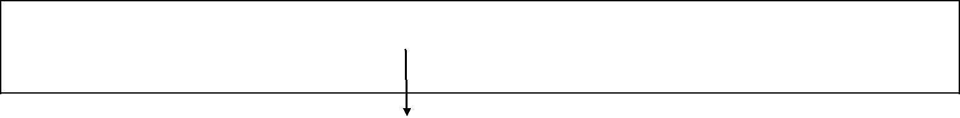

SQL>Insert Into EMP Values (e_id_seq.NEXTVAL,’JAK’,’MANAGER’,1234,’01-jan-08’,30)

Sequence is used to insert empno values in the

EMP table.

Example of using sequence to insert value in student table

SQL>INSERT INTO Student VALUES('NANDAKUMARAN',studentid.NEXTVAL,2,'B',

'30-MAY-2005',80,'NANDAKUMARAN@YAHOO.COM');

Drop Sequence

Once you have created your sequence in Oracle, you might find that you need to remove it

from the database.

Syntax

The syntax to a drop a sequence in Oracle is:

DROP SEQUENCE sequence_name;

sequence_name is the name of the sequence that you wish to drop.

For example:

DROP SEQUENCE studentid;

This example would drop the sequence called studentid.

INDEX

An index is a database object that speeds up the data retrieval process. Characteristics of an index :
  - It is independent of the data from the associated table
- • It occupies space in the table

  - It reduces disk I/O by locating data quickly

Creating an Index

An index can be created manually or automatically:

Manual creation:User can create index manually on columns to speed up the data retrieval process.

Automatic creation:A unique index is created automatically,when a PRIMARY KEY or UNIQUE constraint is defined in a table.

Syntax

SQL> CREATE [UNIQUE] INDEX INDEX_NAME ON TABLE_NAME (COLUMN1,COLUMN2,…COLUMN_N)

Confirming an Index

USER_INDEXES data dictionary view contains the name of the INDEX and its uniqueness.

SQL> Select index_name,index_type,uniqueness from user_indexes;

Example:

CREATE INDEX Student_idx

ON student(registerno);

In this example, we've created an index on the student table called student_idx. It consists of only one field - the registerno field.

We could also create an index with more than one field as in the example below:

CREATE INDEX Student_idx

ON student (registerno,name);

Drop an index

Syntax

The syntax for dropping an index is:

DROP INDEX index_name;

EXAMPLE

DROP INDEX student_idx;

Result

Thus the creation of Simple Views, Complex Views Synonyms, Sequence, Indexes and Save point were successfully completed.

Ex. No :6
Implicit and Explicit Cursors
Date :

Aim :

To implement Implicit and Explicit Cursors.

Procedure:

The oracle engine uses a work area for its internal processing in order to execute an SQL statement. This work area is private to SQL’s operations and is called a cursor. A cursor is a mechanism by which you can assign a name to a "select statement" and manipulate the information within that SQL statement.

There are two types of Cursors.

Inplicit Cursors
Explicit Cursors

Both the types of Cursors have following General attributes.

Attribute Name Description

%ISOPEN returns true if cursor is open, false otherwise

%FOUND returns true if record was fetched successfully, false otherwise.
%NOTFOUND returns true if record was not fetched successfully, false otherwise.

%ROWCOUNT returns number of records processed from the cursor.

Implicit cursor attributes can be used to access information about status of last insert, update, delete or single - row select statement. This can be done by preceding the implicit cursor attribute with cursor name (i.e. sql)

Explicit cursor is defined in the declarative part of a pl/sql block. This is done by naming the cursor and mapping it to a query.

The commands used to control the cursor are DECLARE, OPEN, FETCH and CLOSE.

- Oracle/PLSQL: Declare a Cursor

A cursor is a SELECT statement that is defined within the declaration section of your PLSQL code. We'll take a look at three different syntaxes for cursors.

1. Cursor without parameters (simplest)

The basic syntax for a cursor without parameters is:

CURSOR cursor_name

IS
SELECT_statement;

2. Cursor with parameters

The basic syntax for a cursor with parameters is:

CURSOR cursor_name (parameter_list)

IS
SELECT_statement;

3. Cursor with return clause

The basic syntax for a cursor with a return clause is:

CURSOR cursor_name

RETURN field%ROWTYPE
IS

SELECT_statement;

- Oracle/PLSQL: OPEN Statement

Once you've declared your cursor, the next step is to open the cursor.

The basic syntax to OPEN the cursor is:

OPEN cursor_name;

- Oracle/PLSQL: FETCH Statement

The purpose of using a cursor, in most cases, is to retrieve the rows from your cursor so that some type of operation can be performed on the data. After declaring and opening your cursor, the next step is to FETCH the rows from your cursor.

The basic syntax for a FETCH statement is:

FETCH cursor_name INTO <list of variables>;

- Oracle/PLSQL: CLOSE Statement

The final step of working with cursors is to close the cursor once you have finished using it.

The basic syntax to CLOSE the cursor is:

CLOSE cursor_name;

Result

Thus the implementation of Implicit and Explicit cursors were successfully completed.

Ex. No :7
Integrity Constraints
Date :

Aim

To study the various constraints available in the SQL query language.

DOMAIN INTEGRITY CONSTRAINTS

NOT NULL CONSTRAINT

SQL> create table empl (enamevarchar2(30) not null, eid varchar2(20) not null);
Table created.

SQL> insert into empl values ('abcde',11);

1 row created.

SQL> insert into empl values ('fghij',12);
1 row created.

SQL> insert into empl values ('klmno',null);

insert into empl values ('klmno',null)

*
ERROR at line 1:

ORA-01400: cannot insert NULL into ("ITA"."EMPL"."EID")

SQL> select * from empl;
ENAME EID
------------------------------ --------------------

abcde 11
fghij 12

CHECK AS A COLUMN CONSTRAINT

SQL> create table depts( dname varchar2(30) not null, did number(20) not null check
(did<10000));
Table created.

SQL> insert into depts values ('sales ',9876);
1 row created.

SQL> insert into depts values
('marketing',5432); 1 row created.

SQL> insert into depts values ('accounts',789645);

insert into depts values ('accounts',789645)

*ERROR at line 1:
ORA-02290: check constraint (ITA.SYS_C003179)
violated SQL> select * from depts;

DNAME DID
------------------------------ ---------

sales 9876
marketing 5432

CHECK AS A TABLE CONSTRAINT

SQL> create table airports (anamevarchar2(30) not null , aid number(20) not null, acity

varchar2(30) check( acity in ('chennai','hyderabad','bangalore'))); Table created.

SQL> insert into airports values( 'abcde', 100,'chennai'); 1 row created.

SQL> insert into airports values( 'fghij', 101,'hyderabad'); 1 row created.

SQL> insert into airports values( 'klmno', 102,'bangalore'); 1 row created.

SQL> insert into airports values( 'pqrst', 103,'mumbai'); insert into airports values( 'pqrst', 103,'mumbai')
*

ERROR at line 1:
ORA-02290: check constraint (ITA.SYS_C003187) violated

SQL> select * from airports;
ANAME AID ACITY

------------------------------ --------- ------------------------------

abcde | 100 | chennai
fghij | 101 | hyderabad
klmno | 102 | bangalore

ENTITY INTEGRITY CONSTRAINTS
UNIQUE AS A COLUMN CONSTRAINT

SQL> create table book (bnamevarchar2(30) not null, bid number(20) not null unique); Table created.

SQL> insert into book values ('fairy tales',1000); 1 row created.

SQL> insert into book values ('bedtime stories',1001); 1 row created.
SQL> insert into book values ('comics',1001);

insert into book values ('comics',1001)

*
ERROR at line 1:

ORA-00001: unique constraint (ITA.SYS_C003130) violated

SQL> select * from book;

BNAME BID

------------------------------ ---------

fairy tales 1000
bedtime stories 1001

UNIQUE AS A TABLE CONSTRAINT

SQL> create table orders(oname varchar2(30) not null , oid number(20) not null

- unique(oname,oid)); Table created.

SQL> insert into orders values ('chair', 2005);

1 row created.

SQL> insert into orders values ('table',2006);

1 row created.

SQL> insert into orders values ('chair',2007);
1 row created.

SQL> insert into orders values ('chair', 2005);

insert into orders values ('chair', 2005)

*
ERROR at line 1:

ORA-00001: unique constraint (ITA.SYS_C003152) violated SQL> select * from orders;

ONAME OID
------------------------------ ---------
chair 2005

table 2006
chair 2007

PRIMARY KEY AS A COLUMN CONSTRAINT

SQL> create table custo( cname varchar2(30) not null , cid number(20) not null primary key);

Table created.
SQL> insert into custo values ( 'jones', 506);
1 row created.

SQL> insert into custo values ('hayden',508);

1 row created.

SQL> insert into custo values ('ricky',506);

insert into custo values ('ricky',506)

*

ERROR at line 1:
ORA-00001: unique constraint (ITA.SYS_C003165) violated

SQL> select * from custo;
CNAME CID

------------------------------ ---------
jones 506
hayden 508

PRIMARY KEY AS A TABLE CONSTRAINT

SQL> create table branches(bname varchar2(30) not null , bid number(20) not null , primary key(bname,bid));

Table created.

SQL> insert into branches values ('annanagar', 1005); 1 row created.

SQL> insert into branches values ('adyar',1006);
1 row created.

SQL> insert into branches values ('anna nagar',1007); 1 row created.

SQL> insert into branches values ('annanagar', 1005); insert into branches values ('annanagar', 1005)

*
ERROR at line 1:

ORA-00001: unique constraint (ITA.SYS_C003173) violated SQL> select * from branches;

BNAME BID
------------------------------ ---------

annanagar | 1005
adyar | 1006
annanagar | 1007

REFERENTIAL INTEGRITY CONSTRAINTS

TO CREATE ‘DEPTS’ TABLE

SQL> create table depts(city varchar2(20), dno number(5) primary key); Table created.

SQL> insert into deptsvalues('chennai', 11);
1 row created.

SQL> insert into deptsvalues('hyderabad', 22);
1 row created.

TO CREATE ‘SEMP’ TABLE
SQL> create table semp(ename |  | varchar2(20), dno number(5) references depts(dno));
Table created.
SQL> insert into sempvalues('x', |  | 11);
1 row created.
SQL> insert into sempvalues('y', |  | 22);
1 row created.
SQL> select * from semp;
ENAME | DNO
-------------------- ---------
x | 11
y | 22

ALTER TABLE

SQL> alter table sempadd(eddress
varchar2(20)); Table altered.

SQL> update semp set eddress='10 gandhi road' where dno=11; 1 row updated.

SQL> update semp set eddress='12 m.g. road' where dno=22; 1 row updated.

SQL> select * from semp;
ENAME |  | DNO | EDDRESS
-------------------- --------- --------------------
x |  | 11 | 10 gandhi road
y |  | 22 | 12 m.g. road
SQL> select city, ename from depts, s2emp where depts.dno = s2emp.dno;
CITY |  | ENAME
-------------------- --------------------
chennai |  | x
hyderabad |  | y
Result
Thus the various |  | constraints were implemented and the tables were created successfully.

Ex. No: 8

Study of PL / SQL Block
Date :

Aim

To Study PL / SQL Block

PL/SQL stands for Procedural Language extension of SQL.

PL/SQL is a combination of SQL along with the procedural features of programming languages.

It was developed by Oracle Corporation in the early 90’s to enhance the capabilities of SQL.

The PL/SQL Engine:

Oracle uses a PL/SQL engine to processes the PL/SQL statements. A PL/SQL code can be stored in the client system (client-side) or in the database (server-side).

PL/SQL Block consists of three sections:

• The Declaration section (optional).

• The Execution section (mandatory).

- The Exception (or Error) Handling section (optional).

Declaration Section:

The Declaration section of a PL/SQL Block starts with the reserved keyword DECLARE. This section is optional and is used to declare any placeholders like variables, constants, records and cursors, which are used to manipulate data in the execution section. Placeholders may be any of Variables, Constants and Records, which stores data temporarily. Cursors are also declared in this section.

Execution Section:

The Execution section of a PL/SQL Block starts with the reserved keyword BEGIN and ends with END. This is a mandatory section and is the section where the program logic is written to perform any task. The programmatic constructs like loops, conditional statement and SQL statements form the part of execution section.
Exception Section:

The Exception section of a PL/SQL Block starts with the reserved keyword EXCEPTION. This section is optional. Any errors in the program can be handled in this section, so that the PL/SQL Blocks terminates gracefully. If the PL/SQL Block contains exceptions that cannot be handled, the Block terminates abruptly with errors.

Every statement in the above three sections must end with a semicolon ; . PL/SQL blocks can be nested within other PL/SQL blocks. Comments can be used to document code.

Sample PL/SQL Block:

DECLARE

Variable declaration
BEGIN

Program Execution
EXCEPTION
Exception handling

END;

The 'Hello World' Example:

DECLARE

message varchar2(20):= 'Hello, World!';
BEGIN

dbms_output.put_line(message);

END;

/

The end; line signals the end of the PL/SQL block. To run the code from SQL command line, we need to type / at the beginning of the first blank line after the last line of the code. When the above code is executed at SQL prompt, it produces following result:

Hello World

PL/SQL procedure successfully completed.
Comment

A comment is text that the PL/SQL compiler ignores. Its primary purpose is to document code, but we can also disable obsolete or unfinished pieces of code by turning them into comments. PL/SQL has both single-line and multiline comments. --

Turns the rest of the line into a single-line comment. Any text that wraps to the next line is not

part of the comment.

/*

Begins a comment, which can span multiple lines.

*/

Ends a comment.

PL/SQL - Constants and Literals

A constant holds a value that once declared, does not change in the program. A constant declaration specifies its name, data type, and value, and allocates storage for it. The declaration can also impose the NOT NULL constraint.

Declaring a Constant

A constant is declared using the CONSTANT keyword. It requires an initial value and does not

allow that value to be changed. For example:

DECLARE

- constant declaration pi constant number :=

3.141592654; -- other declarations radius number(5,2);

dia number(5,2);

circumference number(7, 2); area number (10, 2); BEGIN

- processing

radius := 9.5; dia

:= radius * 2;

circumference := 2.0 * pi * radius;

area := pi * radius * radius;

-- output

dbms_output.put_line('Radius: ' || radius);
dbms_output.put_line('Diameter: ' || dia);

dbms_output.put_line('Circumference: ' || circumference); dbms_output.put_line('Area: ' || area); END;

/

When the above code is executed at SQL prompt, it produces the following result:

Radius: 9.5
Circumference: 59.69

Area: 283.53
Pl/SQL procedure successfully completed.

Diameter: 19

PL/SQL – Conditions

Decision-making structures require that the programmer specify one or more conditions to be evaluated or tested by the program, along with a statement or statements to be executed if the condition is determined to be true, and optionally, other statements to be executed if the condition is determined to be false.

IF-THEN Statement

It is the simplest form of IF control statement, frequently used in decision making and changing the control flow of the program execution.

Syntax:

Syntax for IF-THEN statement is:

IF condition THEN
S;

END IF;

Where condition is a Boolean or relational condition and S is a simple or compound statement.
Example of an IF-THEN statement is:

IF (a <= 20)
THEN c:= c+1;
END IF;

Flow Diagram:
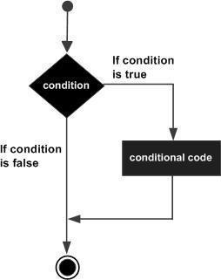

IF-THEN-ELSE Statement

A sequence of IF-THEN statements can be followed by an optional sequence of ELSE statements, which execute when the condition is FALSE.

Syntax:

Syntax for the IF-THEN-ELSE statement is:

IF condition THEN
S1;

ELSE
S2;

END IF;

Where, S1 and S2 are different sequence of statements. In the IF-THEN-ELSE statements, when the test condition is TRUE, the statement S1 is executed and S2 is skipped; when the test condition is FALSE, then S1 is bypassed and statement S2 is executed. For example,
IF color = red THEN

dbms_output.put_line('You have chosen a red car') ELSE

dbms_output.put_line('Please choose a color for your car'); END IF;

Flow Diagram:
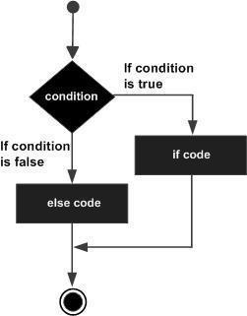
IF-THEN-ELSIF Statement

The IF-THEN-ELSIF statement allows you to choose between several alternatives. An IF-THEN statement can be followed by an optional ELSIF...ELSE statement. The ELSIF clause lets

you add additional conditions.

When using IF-THEN-ELSIF statements there are few points to keep in mind.   ➢ It's ELSIF, not ELSEIF  
  - An IF-THEN statement can have zero or one ELSE's and it must come after any ELSIF's.  

- ➢ An_{ELSE.}IF-THEN  statement can have zero to many ELSIF's and they must come before the Once an ELSIF succeeds, none of the remaining ELSIF's or ELSE's will be tested.  ➢

Syntax:

The syntax of an IF-THEN-ELSIF Statement in PL/SQL programming language is:

IF(boolean_expression 1)THEN

S1; -- Executes when the boolean expression 1 is true
ELSIF(boolean_expression 2) THEN

S2; -- Executes when the boolean expression 2 is true
ELSIF(boolean_expression 3) THEN
S3; -- Executes when the boolean expression 3 is true

ELSE
S4; -- executes when the none of the above condition is true

END IF;

PL/SQL – Loops

There may be a situation when you need to execute a block of code several number of times. In general, statements are executed sequentially: The first statement in a function is executed first, followed by the second, and so on.

Programming languages provide various control structures that allow for more complicated execution paths.

A loop statement allows us to execute a statement or group of statements multiple times and following is the general form of a loop statement in most of the programming languages:
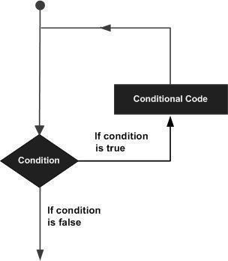

Basic Loop Statement

Basic loop structure encloses sequence of statements in between the LOOP and END LOOPstatements. With each iteration, the sequence of statements is executed and then control resumes at the top of the loop.

Syntax:

The syntax of a basic loop in PL/SQL programming language is:

LOOP

Sequence of statements;
END LOOP;

Here, sequence of statement(s) may be a single statement or a block of statements. An EXIT statement or an EXIT WHEN statement is required to break the loop.
WHILE LOOP Statement

A WHILE LOOP statement in PL/SQL programming language repeatedly executes a target statement as long as a given condition is true.

Syntax:

WHILE condition LOOP

sequence_of_statements

END LOOP;

FOR LOOP Statement

A FOR LOOP is a repetition control structure that allows you to efficiently write a loop that needs to execute a specific number of times.

Syntax:

FOR counter IN initial value..final value LOOP
sequence_of_statements;
END LOOP;

Following are some special characteristics of PL/SQL for loop:
- The initial_value and final_value of the loop variable or counter can be literals, variables, or
expressions but must evaluate to numbers. Otherwise, PL/SQL raises the predefined exception VALUE_ERROR.
- initial_value need not to be 1; however, the loop counter increment (or decrement) must be 1.

- PL/SQL allows determine the loop range dynamically at run time.

Nested Loops

PL/SQL allows using one loop inside another loop. Following section shows few examples to illustrate the concept.

The syntax for a nested basic LOOP statement in PL/SQL is as follows:

LOOP

Sequence of statements1
LOOP

Sequence of statements2
END LOOP;
END LOOP;

The syntax for a nested FOR LOOP statement in PL/SQL is as follows:

FOR counter1 IN initial_value1 ..final_value1 LOOP sequence_of_statements1

FOR counter2 IN initial_value2 ..final_value2
LOOP sequence_of_statements2
END LOOP;
END LOOP;

The syntax for a nested WHILE LOOP statement in Pascal is as follows:

WHILE condition1 LOOP
sequence_of_statements1

WHILE condition2 LOOP
sequence_of_statements2

END LOOP;
END LOOP;

Result

Thus the study of PL / SQL was successfully completed.

Ex. No: 9

Date:

Aim

Programming Language Extensions to Satisfy Conditions

To write PL/SQL block to satisfy conditions

TO DISPLAY HELLO MESSAGE

SQL> set serveroutput on;

SQL> declare
- a varchar2(20);
- begin

- a:='Hello';
- dbms_output.put_line(a);

- end;
- /
Hello

PL/SQL procedure successfully completed.

TO INPUT A VALUE FROM THE USER AND DISPLAY IT

SQL> set serveroutput on;
SQL> declare
- a varchar2(20);

- begin
- a:=&a;

- dbms_output.put_line(a);
- end;

- /

Enter value for a: 5
old 4: a:=&a; new
- a:=5;
5

PL/SQL procedure successfully completed.

GREATEST OF THREE NUMBERS

SQL> set serveroutput on;

SQL> declare
- a number(7);

- b number(7);
- c number(7);

- begin
- a:=&a;

- b:=&b;
- c:=&c;

- if(a>b and a>c) then
- dbms_output.put_line (' The greatest of the three is ' || a);
- else if (b>c) then

- dbms_output.put_line (' The greatest of the three is ' || b);
- else

- dbms_output.put_line (' The greatest of the three is ' || c);
- end if;

- end if;

- end;
- /

Enter value for a: 5
old 6: a:=&a; new

- a:=5; Enter value for b: 7 old

- b:=&b; new 7: b:=7; Enter value for c: 1 old 8: c:=&c; new 8: c:=1;

The greatest of the three is 7

PL/SQL procedure successfully completed.

PRINT NUMBERS FROM 1 TO 5 USING SIMPLE LOOP

SQL> set serveroutput on;
SQL> declare
- a number:=1;

- begin
- loop

- dbms_output.put_line (a);
- a:=a+1;

- exit when a>5;

- end loop;
- end;

- /
1
2

3
4

5
PL/SQL procedure successfully completed.

PRINT NUMBERS FROM 1 TO 4 USING WHILE LOOP

SQL> set serveroutput on;

SQL> declare
- a number:=1;
- begin

- while(a<5)
- loop

- dbms_output.put_line (a);
- a:=a+1;

- end loop;

- end;
- /

1
2
3

4

PL/SQL procedure successfully completed.

PRINT NUMBERS FROM 1 TO 5 USING FOR LOOP

SQL> set serveroutput on;
SQL> declare

- a number:=1;
- begin
- for a in 1..5

- loop
- dbms_output.put_line (a);

- end loop;
- end;
- /

1
2

3
4
5

PL/SQL procedure successfully completed.

TO CREATE SACCOUNT TABLE

SQL> create table saccount (accno number(5), name varchar2(20), bal number(10));

Table created.

SQL> insert into saccount values ( 1,'mala',20000);

1 row created.

SQL> insert into saccount values (2,'kala',30000);

1 row created.

SQL> select * from saccount;

ACCNO NAME BAL

--------- -------------------- ---------
1 mala 20000

2 kala 30000

SQL> set serveroutput on;

SQL> declare
- a_bal number(7);

- a_no varchar2(20);
- debit number(7):=2000;
- minamt number(7):=500;

- begin
- a_no:=&a_no;

- selectbal into a_bal from saccount where accno= a_no;
- a_bal:= a_bal-debit;
- if (a_bal>minamt) then

- updatesaccount set bal=bal-debit where accno=a_no;
- end if;

- end;
14
15 /

Enter value for a_no: 1
old 7: a_no:=&a_no;
new 7: a_no:=1;

PL/SQL procedure successfully completed.

SQL> select * from saccount;

ACCNO NAME BAL
--------- -------------------- ---------

1 mala 18000
2 kala 30000

Result

Thus the various programs in PL/SQL were implemented and their output was verified.

Ex. No : 10
Procedures and Functions
Date:

Aim

To write PL/SQL programs that executes the concept of functions and procedures.

Definition

A procedure or function is a logically grouped set of SQL and PL/SQL statements
that perform a specific task. They are essentially sub-programs. Procedures and functions
are made up of,
• Declarative part
• Executable part

• Optional exception handling part
These procedures and functions do not show the errors.

KEYWORDS AND THEIR PURPOSES

REPLACE: It recreates the procedure if it already exists.

PROCEDURE: It is the name of the procedure to be created.

ARGUMENT: It is the name of the argument to the procedure. Paranthesis can be omitted if no arguments are present.

IN: Specifies that a value for the argument must be specified when calling the procedure ie.
used to pass values to a sub-program. This is the default parameter.

OUT: Specifies that the procedure passes a value for this argument back to it’s calling environment after execution ie. used to return values to a caller of the sub-program.

INOUT: Specifies that a value for the argument must be specified when calling the procedure and that procedure passes a value for this argument back to it’s calling environment after execution.

RETURN: It is the datatype of the function’s return value because every function must return a value, this clause is required.

PROCEDURES – SYNTAX

create or replace procedure <procedure name> (argument {in,out,inout} datatype ) {is,as} variable declaration;

constant
declaration; begin
PL/SQL subprogram
body; exception

exception PL/SQL
block; end;

FUNCTIONS – SYNTAX

create or replace function <function name> (argument in datatype,……) return datatype

{is,as}

variable declaration;

constant declaration;

begin

PL/SQL subprogram
body; exception

exception PL/SQL
block; end;

CREATING THE TABLE ‗ITITEMS‘ AND DISPLAYING THE CONTENTS

SQL> create table ititems(itemid number(3), actualprice number(5), ordid number(4), prodid number(4));

Table created.

SQL> insert into ititems values(101,2000, 500, 201); 1 row created.

SQL> insert into ititems values(102,3000, 1600, 202); 1 row created.

SQL> insert into ititems values(103,4000, 600, 202); 1 row created.

SQL> select * from ititems;
ITEMID ACTUALPRICE |  | ORDID | PRODID
--------- | ----------- | -------- | ---------
101 | 2000 | 500 | 201
102 | 3000 | 1600 | 202
103 | 4000 | 600 | 202

PROGRAM FOR GENERAL PROCEDURE – SELECTED RECORD‘S PRICE IS INCREMENTED BY 500 , EXECUTING THE PROCEDURE CREATED AND DISPLAYING THE UPDATED TABLE

SQL> create procedure itsum(identity number, total number) is price number; 2 null_price exception;
- begin

- select actualprice into price from ititems where itemid=identity;
- if price is null then

- raise null_price;
- else
8 update ititems set actualprice=actualprice+total where itemid=identity;
9 end if;

- exception
- when null_price then

- dbms_output.put_line('price is null');
- end;
- /

Procedure created.

SQL> exec itsum(101, 500);
PL/SQL procedure successfully completed.

SQL> select * from ititems;
ITEMID | ACTUALPRICE | ORDID | PRODID
--------- | ----------- | --------- | ---------
101 | 2500 | 500 | 201
102 | 3000 | 1600 | 202
103 | 4000 | 600 | 202

PROCEDURE FOR ‗IN‘ PARAMETER – CREATION, EXECUTION SQL> set serveroutput on;
SQL> create procedure yyy (a IN number) is price number;

- begin
- select actualprice into price from ititems where itemid=a;

- dbms_output.put_line('Actual price is ' || price);
- if price is null then
- dbms_output.put_line('price is null');

- end if;
- end;

- /
Procedure created.

SQL> exec yyy(103);
Actual price is 4000

PL/SQL procedure successfully completed.

PROCEDURE FOR ‗OUT‘ PARAMETER – CREATION, EXECUTION

SQL> set serveroutput on;
SQL> create procedure zzz (a in number, b out number) is identity number;

- begin
- select ordid into identity from ititems where itemid=a;
- if identity<1000 then

- b:=100;
- end if;

- end;
- /
Procedure created.
SQL> declare

- a number;
- b number;

- begin
- zzz(101,b);
- dbms_output.put_line('The value of b is '|| b);

- end;
- /

The value of b is 100
PL/SQL procedure successfully completed.

PROCEDURE FOR ‗INOUT‘ PARAMETER – CREATION, EXECUTION

SQL> create procedure itit ( a in out number) is
- begin
- a:=a+1;

- end;
- /

Procedure created.

SQL> declare

- a number:=7;
- begin

- itit(a);
- dbms_output.put_line(‘The updated value is ‘||a);
- end;

- /
The updated value is 8

PL/SQL procedure successfully completed.

CREATE THE TABLE ‗ITTRAIN‘ TO BE USED FOR FUNCTIONS

SQL>create table ittrain ( tno number(10), tfare
number(10)); Table created.

SQL>insert into ittrain values (1001, 550);

1 row created.

SQL>insert into ittrain values (1002, 600);
1 row created.
SQL>select * from ittrain;

TNO TFARE
--------- ------------

1001 550

1002 600
PROGRAM FOR FUNCTION AND IT‘S EXECUTION

SQL> create function aaa (trainnumber number) return number is 2 trainfunction ittrain.tfare % type;

- begin
- select tfare into trainfunction from ittrain where tno=trainnumber;
- return(trainfunction);

- end;
- /

Function created.

SQL> set serveroutput on;

SQL> declare
- total number;
- begin

- total:=aaa (1001);
- dbms_output.put_line('Train fare is Rs. '||total);

- end;
- /

Train fare is Rs.550

PL/SQL procedure successfully completed.

FACTORIAL OF A NUMBER USING FUNCTION — PROGRAM AND EXECUTION

SQL> create function itfact (a number) return number is

- fact number:=1;
- b number;
- begin

- b:=a;
- while b>0

- loop
- fact:=fact*b;

- b:=b-1;

- end loop;
- return(fact);

- end;
- /

Function created.

SQL> set serveroutput on;

SQL> declare

- a number:=7;
- f number(10);

- begin
- f:=itfact(a);

- dbms_output.put_line(‘The factorial of the given number is’||f);

- end;
- /

The factorial of the given number is 5040

PL/SQL procedure successfully completed.

Result

Thus the PL/SQL programs were executed successfully.

Ex. No. 11
Triggers
Date:

Aim

To write triggers using Oracle PL/SQL

Theory

In a DBMS, a trigger is a SQL procedure that initiates an action (i.e., firesan action) when an event (INSERT, DELETE or UPDATE) occurs. Since triggers are event-driven specialized procedures, they are stored in and managed by the DBMS. A trigger cannot be called or executed; the DBMS automatically fires the trigger as a result of a data modification to the associated table.

A trigger can also contain INSERT, UPDATE and DELETE logic within itself, so when the trigger is fired because of data modification it can also cause another data modification, thereby firing another trigger. A trigger that contains data modification logic within itself is called a nested trigger.

Syntax

The CREATE TRIGGER command defines and names a trigger that will be stored in the database.

CREATE [ OR REPLACE ] TRIGGER name

{ BEFORE | AFTER } { INSERT | UPDATE | DELETE } [ OR { INSERT | UPDATE | DELETE } ]... ON

table

[ FOR EACH ROW

] [DECLARE

declarations ]

BEGIN

statements

END;
Types of Triggers

Oracle supports both row-level and statement-leveltriggers. A row-level trigger fires once for each row that is affected by a triggering event. For example, if deletion is defined as a triggering event on a table and a single DELETE command is issued that deletes five rows from the table, then the trigger will fire five times, once for each row.

In contrast, a statement-level trigger fires once per triggering statement regardless of the number of rows affected by the triggering event. In the prior example of a single DELETE command deleting five rows, a statement-level trigger would fire only once.

The sequence of actions can be defined regarding whether the trigger code block is executed before or after the triggering statement, itself, in the case of statement-level triggers; or before or after each row is affected by the triggering statement in the case of row-level triggers.

In a before row-level trigger, the trigger code block is executed before the triggering action is carried out on each affected row. In a before statement-level trigger, the trigger code block is executed before the action of the triggering statement is carried out.

In an after row-level trigger, the trigger code block is executed after the triggering action is carried out on each affected row. In an after statement-level trigger, the trigger code block is executed after the action of the triggering statement is carried out.

Example:

SQL>CREATE OR REPLACE TRIGGER

student_alert_trig BEFORE INSERT ON student

BEGIN

DBMS_OUTPUT.PUT_LINE('New Student Record is about to be added'); END;

Sample Output :
SQL> INSERT INTO Student VALUES('ADITYA KUMAR',11305104005,2,'A','24 -JUL-2005',99,'ADITYAKUMAR@GMAIL.com');

New Student Record is about to be

added 1 row created.

The message, ―New Student Record is about to be added‖, is displayed once by the firing of the trigger even though the result is the addition of three new rows.
Exercise

- Write a after statement-level trigger. Whenever an insert, update, or delete operation occurs on the Student table, a row is added to the Studentauditlogtable recording the date, user, and Action. Name the Trigger as Student_Audit_trig.

Step 1: Create a table Studentauditlog with following Fields Field Name Data Type

Audit_date Date

Audit_user Varchar2(25)

Audit_desc VARCHAR2(50)

SQL>CREATE TABLE VARCHAR2(25), audit_desc

studentauditlog

VARCHAR2(50));

(audit_dateDATE,audit_user

Step 2: Create Trigger Named student_audit_trig SQL>CREATE OR REPLACE TRIGGER

student_audit_trig AFTER INSERT OR UPDATE OR DELETE ON student DECLARE

v_actionVARCHAR2(50);

BEGIN

IF INSERTING THEN

v_action := 'Added Student(s)';

ELSIF UPDATING THEN

v_action := 'Updated
Student(s)'; ELSIF DELETING THEN

v_action := 'Deleted
Student(s)'; END IF;

INSERT INTO studentauditlog VALUES (SYSDATE, USER,v_action); END;

Step 3: Verify Trigger

SQL>INSERT INTO Student VALUES('ADITYA KUMAR',11305104005,2,'A','24-JUL-2005',99,'ADITYAKUMAR@GMAIL.com');

New Student Record is about to be added

1 row created.

SQL> select * from studentauditlog;

AUDIT_DAT AUDIT_USER AUDIT_DESC

--------- ------------------------- --------------------

30-NOV-09 I7205312 Added Student(s)

- Write a Before row-level trigger that displays a message Number 3' before every new student belonging to Branch student table. Name the Trigger as Student_Branch3_trig.

'New Students are added to Branch Number 3 is inserted into the

CREATE OR REPLACE TRIGGER
Student_Branch3_trig BEFORE INSERT ON student

FOR EACH
ROW BEGIN

IF :NEW.branchno = 3 THEN

DBMS_OUTPUT.PUT_LINE('New Student(s )are added to Branch Number3(Electrical)’);

END IF;

END;

NOTE : Trigger Variables

In the trigger code block, several special variables are available for use.

NEW

NEW is a pseudo-record name that refers to the new table row for insert and update operations in row-level triggers. This variable is not applicable in statement-level triggers and in delete operations of row-level triggers.

Its usage is: :NEW.column where column is the name of a column in the table on which the trigger is defined.

The initial content of :NEW.column is the value in the named column of the new row to be inserted or of the new row that is to replace the old one when used in a before row-level trigger. When used in an after row-level trigger, this value has already been stored in the table since the action has already occurred on the affected row.

In the trigger code block, :NEW.column can be used like any other variable. If a value is assigned to :NEW.column, in the code block of a before row-level trigger, the assigned value will be used in the new inserted or updated row.

- Write a Row level Trigger that displays a message prior to Delete operation on the Student table. Name the Trigger as Student_DeleteAlert_trig.

CREATE OR REPLACE TRIGGER
Student_DeleteAlert_trig BEFORE DELETE ON student

FOR EACH
ROW BEGIN

DBMS_OUTPUT.PUT_LINE('Student(s)Records are about to be Deleted'); END;

Result

Thus the triggers in Oracle PL/SQL was successfully completed.

Ex. No: 12
PL / SQL Blocks - Handling Exceptions

Date:

Aim

To Write a PL / SQL block that handles all types of exceptions.

Theory

An error condition during a program execution is called an exception in PL/SQL. PL/SQL

supports programmers to catch such conditions using EXCEPTION block in the program and an

appropriate action is taken against the error condition. There are two types of exceptions:

  | ➢ | System-defined exceptions  
  | ➢ | User-defined exceptions  
Syntax for Exception Handling  

The General Syntax for exception handling is as follows. Here you can list down as many as exceptions you want to handle. The default exception will be handled using WHEN others THEN:

DECLARE
<declarations
section> BEGIN

<executable command(s)>

EXCEPTION

<exception handling goes here >
WHEN exception1 THEN
exception1-handling-statements
WHEN exception2 THEN
exception2-handling-statements
WHEN exception3 THEN
exception3-handling-statements

........

WHEN others THEN
exception3-handling-
statements END;

Example

Let us write some simple code to illustrate the concept. We will be using the employee205 table

we had created and used in the previous Exercise No 4:

DECLARE

pssn number(4);
pfname varchar2(15);
pbdate date;

BEGIN

SELECT fname, bdate INTO pfname, pbdate FROM employee205
WHERE ssn = &pssn;

DBMS_OUTPUT.PUT_LINE ('Name: '|| pfname);
DBMS_OUTPUT.PUT_LINE ('Date of Birth: ' || pbdate);

EXCEPTION

WHEN no_data_found THEN
dbms_output.put_line('No such
Employee!'); WHEN others THEN
dbms_output.put_line('Error!');
END;

When the above code is executed at SQL prompt, it produces the following result:

Execution 1:
Enter value for pssn: 999

old | 8: | WHERE ssn | = &pssn;
new | 8: | WHERE ssn | = 999;
Name: NANDA
Date of Birth: 30-MAY-05

PL/SQL procedure successfully completed.

Execution 2:

Enter value for pssn: 100

old | 8: | WHERE | ssn | = | &pssn;
new | 8: | WHERE | ssn | = | 100;
No such Employee!

PL/SQL procedure successfully completed.
Raising Exceptions

Exceptions are raised by the database server automatically whenever there is any internal

database error, but exceptions can be raised explicitly by the programmer by using the command

RAISE. Following is the simple syntax of raising an exception:

DECLARE

exception_name
EXCEPTION; BEGIN

IF condition THEN
RAISE exception_name;
END IF;
EXCEPTION

WHEN exception_name THEN
statement;
END;

We can use above syntax in raising Oracle standard exception or any user-defined exception.
Next section will give an example on raising user-defined exception, similar way we can raise
Oracle standard exceptions as well.

User-defined Exceptions

PL/SQL allows you to define your own exceptions according to the need of your program. A

user-defined exception must be declared and then raised explicitly, using either a RAISE

statement or the procedure

DBMS_STANDARD.RAISE_APPLICATION_ERROR.

The syntax for declaring an exception is:

DECLARE
my-exception EXCEPTION;

Example:

The following example illustrates the concept. This program asks for assn, when the user enters an invalid ssn, the exception invalid_ssn is raised.
DECLARE

pssn number(4);
inputssn number(4);
pfname varchar2(15);
pbdate date;
invalid_ssn EXCEPTION;
BEGIN
PSSN:=&inputssn;

IF Pssn<= 0 THEN
RAISE invalid_ssn;
ELSE

SELECT fname, bdate INTO pfname, pbdate FROM employee205
WHERE ssn = pssn;

DBMS_OUTPUT.PUT_LINE ('Name: '|| pfname);
DBMS_OUTPUT.PUT_LINE ('Date of Birth: ' || pbdate);
END IF;
EXCEPTION
WHEN invalid_ssn THEN

dbms_output.put_line('SSN must be greater than zero!'); WHEN no_data_found THEN

dbms_output.put_line('No such
Employee!'); WHEN others THEN
dbms_output.put_line('Error!');
END;

When the above code is executed at SQL prompt, it produces the following result:

SQL> /

Enter value for inputssn: 999
old 8: PSSN:=&inputssn; new

- PSSN:=999; Name: NANDA
Date of Birth: 30-MAY-05

PL/SQL procedure successfully completed.

SQL> /

Enter value for inputssn: 200
old 8: PSSN:=&inputssn; new
8: PSSN:=200;
No such Employee!

PL/SQL procedure successfully completed.

SQL> /

Enter value for inputssn: 0

old 8: PSSN:=&inputssn; new
8: PSSN:=0;
SSN must be greater than zero!

PL/SQL procedure successfully completed.

Result

Result

Thus the PL / SQL blocks that handle all types of exceptions were successfully completed.

Ex. No: 13
Library Information System
Date:

Aim

To develop an application for automating the Library Information System

Phases of Project Development:

- Requirement Analysis (collect client requirements and analyze it.)

- Design phase(prepare design according to the requirements)

2.1 Database Design:

A good database design is, therefore, one that:

- Divides your information into subject-based tables to reduce redundant data.

- Provides Access with the information it requires to join the information in the tables together as needed.

- Helps support and ensure the accuracy and integrity of your information.

- Accommodates your data processing and reporting needs.

2.1.1 The Design process: The design process consists of the following steps:

Determine the purpose of your database: This helps prepare you for the remaining steps.

2.1.2 Find and organize the information required: Gather all of the types of information you might want to record in the database, such as product name and order number.

2.1.3 Divide the information into tables: Divide your information items into major entities or subjects, such as Products or Orders. Each subject then becomes a table.

2.1.4 Turn information items into columns: Decide what information you want to store in each table. Each item becomes a field, and is displayed as a column in the table. For example, an Employees table might include fields such as Last Name and Hire Date.

2.1.5 Specify primary keys: Choose each table’s primary key. The primary key is a column that is used to uniquely identify each row. An example might be Product ID or Order ID.

2.1.6 Set up the table relationships: Look at each table and decide how the data in one table is related to the data in other tables. Add fields to tables or create new tables to clarify the relationships, as necessary.

2.1.7 Refine your design: Analyze your design for errors. Create the tables and add a few records of sample data. See if you can get the results you want from your tables. Make adjustments to the design, as needed.

2.1.8. Apply the Normalization rules:

2.1.9. Draw Entity Relationship Diagram:

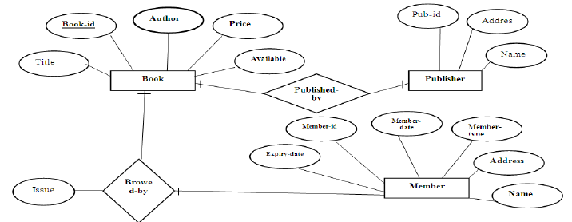

2.2 User Interface Design

These are ten general principles for user interface design. They are called "heuristics" because they are more in the nature of rules of thumb than specific usability guidelines.

2.2.1 Visibility of system status

The system should always keep users informed about what is going on, through appropriate feedback within reasonable time.

2.2.2 Match between system and the real world

The system should speak the users' language, with words, phrases and concepts familiar to the user, rather than system-oriented terms. Follow real-world conventions, making information appear in a natural and logical order.

2.2.3 User control and freedom

Users often choose system functions by mistake and will need a clearly marked "emergency exit" to leave the unwanted state without having to go through an extended dialogue. Support undo and redo.

2.2.4 Consistency and standards

Users should not have to wonder whether different words, situations, or actions mean the same thing. Follow platform conventions.

2.2.5 Error prevention

Even better than good error messages is a careful design which prevents a problem from occurring in the first place. Either eliminate error-prone conditions or check for them and present users with a confirmation option before they commit to the action.

2.2.6 Recognition rather than recall

Minimize the user's memory load by making objects, actions, and options visible. The user should not have to remember information from one part of the dialogue to another. Instructions for use of the system should be visible or easily retrievable whenever appropriate.

2.2.7 Flexibility and efficiency of use

Accelerators -- unseen by the novice user -- may often speed up the interaction for the expert user such that the system can cater to both inexperienced and experienced users. Allow users to tailor frequent actions.

2.2.8 Aesthetic and minimalist design

Dialogues should not contain information which is irrelevant or rarely needed. Every extra of information in a dialogue competes with the relevant units of information and diminishes relative visibility.

2.2.9 Help users recognize, diagnose, and recover from errors

Error messages should be expressed in plain language (no codes), precisely indicate the problem, and constructively suggest a solution.

2.2.10 Help and documentation

Even though it is better if the system can be used without documentation, it may be necessary to provide help and documentation. Any such information should be easy to search, focused on the user's task, list concrete steps to be carried out, and not be too large

unit their

Front End Tool
Visual Basic 6.0 is a robust, object-oriented, sophisticated and powerful development platform,

ideally suited for producing impressive Windows applications.

The major advantages of VB are:

➢ It is a powerful and complete Windows application development _{system that enables us to use} built-in functions and subroutines for dozens of different tasks.

It also provides capability to produce custom libraries and objects that can be loaded at runtime or bound into the distributed application.
 | ➢ ^{It is} a hugely successful product preferred by millions of developers at virtually all
  | ➢ skill levels. |  |  
  |  | It is well supported by third party products
  | ➢ | It supports the principle of object driven design  
 | ➢ | It is very flexible and user-friendly as it is a GUI (Graphic User Interface)  
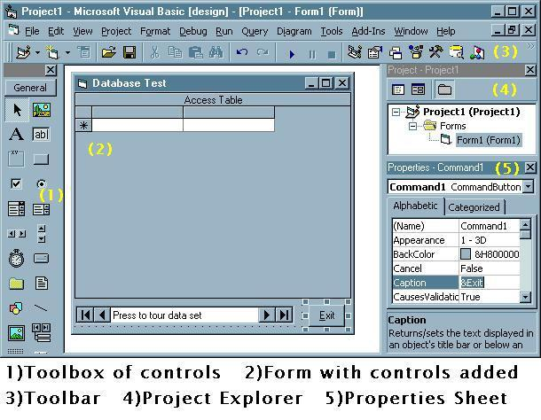

Every time you load a VB or VBA project, you will be greeted by roughly the layout shown in Figure and these five GUI tools. First, the toolbox(1) contains all the GUI

elements/controls needed to create any VB form and the front end to all VB programs. For example, after the pointer tool there is the image control, label, textbox, and frame and command button as the first five of 20 standard controls which are used constantly in VB programs. Another advantage of these basic controls is that they fill 60-90% of all our programming needs and are automatically included in the VB runtime.

Second is form(2). Think of it as yours- you can size it, color it, give it a caption ("Database Test" in this case) and fill the form with GUI controls which help your program do useful works. Putting controls on your form is as easy as clicking on the control (say the command button) in the toolbox and then dragging and sizing it on your form (see the "Exit" button on the form).

The third part of the Basic canvas is the menus and toolbars (3) which manage and control all of VB/VBA.Most of us will be familiar with many of the menu and icons. File, Edit, View, Run, Window, Help menus should be familiar to any Word Perfect, Excel, or Netscape users. Likewise icons for File Open, File Save, Cut, Copy, Paste, Find, Run programs, Pause Program, Halt Program can be seen along the toolbar. Along with built in wizards and custom command centers in some controls, this is the heart of VB.

Fourth is the Project Explorer (4) which you use to access all the forms and coding files in your VB program. The PE-Project Explorer is such a handy navigation device you will find yourself using it all the time to switch among different forms and code.

Fifth and even more frequently used than the Project Explorer is the Properties sheet

(5). Note that the "Exit" command button is highlighted in the form and is also the control listed in the Properties sheet. The Properties sheet is both the elegance and the swamp of VB. If you want to change the property of any control like its color, shape, caption, or whatever - the Property sheet is the place to go. But a command button has 32 properties - and some controls have hundreds, hence the swamp.

You will find in developing in Visual Basic that you spend a large percentage of time using the Project Explorer and Property sheet. It is worthwhile to get to know them well. Project Explorer is your means of navigating around the various parts of VB; while Property sheets allow you to set the very basic look and feel plus behavior of all your forms in Visual Basic.
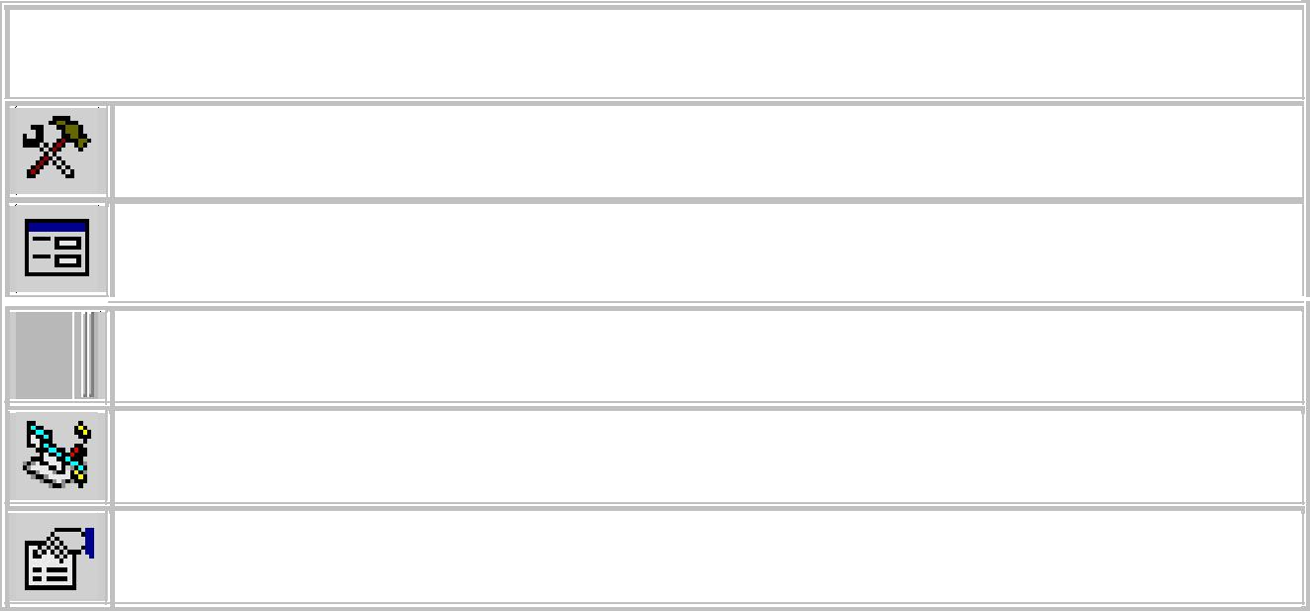
Summary of Major Visual Basic Canvas Features

  - The toolbox icon - toggles the main toolbox of form controls on and off.

  - The form icon in the Project Explorer. Click on this and the active Form will
- appear in the edit window.

  - The toolbar handle. Every toolbar  has one. Pull on it to move/reposition the
- toolbar anywhere on the screen.

  - The Project Explorer icon - toggle this to make the Project Explorer appear or
- disappear.

  - Property sheet  icon - toggle this to make the Property sheet appear or disappear.

Form Design

Develop proper forms

Forms don’t usually get much attention from code-level developers. We add a form and off we go, plugging in various controls and using them as containers for information. But setting up forms’ properties is important for creating visually pleasant, consistent, and intuitive interfaces.

You should specify the proper border style of a form. Your options are:

• None

• Fixed Single

• Sizable

• Fixed Dialog

• Fixed Tool Window

- Sizable Tool Window

Using None is rarely a good idea, since such forms don’t have a title bar or the control menu box, so users can’t close or resize them. The default form value is Sizable (allowing users to

resize the form), but this is a good choice only in cases where all the form elements are designed to resize along with the form itself.

The Fixed Dialog style offers a border and doesn’t allow a form to be resized, but it lacks Minimize and Maximize buttons in the top-right corner. To include those buttons, use the Fixed Single style. Sizable Tool Window and Fixed Tool Window styles are generally used for forms that need to float over and allow changes to be made to the main forms.

You should also address the form’s start position. The available start position styles are:

• Manual

• Windows Default

• CenterScreen

- CenterOwner

The default style is Manual, which means that the form will appear in the same location at both runtime and design time. Windows Default puts a form in the upper-left corner on the screen.

CenterScreen places a form in the center of the user’s screen regardless of the screen resolution. CenterOwner places a form in the center of the owner form. An owner is a form on top of which the current form is to appear. When no owner is specified, the form shows up in the center of the desktop.

Keep controls consistent and appropriate

Before simply dropping controls on a form, consider what kind of data the control will oversee and how your users will interact with that data. The guidelines provided below will help you choose the best controls for a particular type of data.

The first rule of form controls is that they should have consistent characteristics, such as look, feel, and size. Users shouldn't need to learn specific visual cues and usage parameters for each control.

Your text box controls should be the same height as the combo boxes. By default, the height property of text boxes is different from that of the combo boxes. You should change the height value of the text boxes to match that of the combo boxes (since the height property is read-only in combo boxes). Obviously, this rule applies only to single-line text boxes.

You should use the proper controls for the data you need to display. If you're displaying read-only data, you should not use a text box and modify its properties so that users can’t make changes to its text. Instead, use a label. Text box controls should be used only for editable data.

When you need to display fewer than five options in a list and you want the user to choose only one item, option buttons are your best choice. Many applications use combo boxes to display such information, but from the user's standpoint, it’s much better to see all options at once rather than having to scroll through the listings in a combo box.

Keep in mind that when you want your users to be able to select more than one item from a small list of selections, using check boxes is a good idea. As with option buttons, check boxes let
users see all options available at the same time, but check boxes also allow the selection of multiple items from the list.

When you need to display a larger number of items for users to choose from, it’s not feasible to use option buttons or check boxes because of the amount of real estate they would take up on the form. In such cases, you should display data either in combo boxes or list boxes to save space. You can use multiple-selection list boxes to let users select more than one item at a time; combo boxes allow only one item to be selected.

Developers sometimes use combo boxes and list boxes to display more than one column of data; however, grid controls may be easier for users to understand (and easier for you to code).

When using labels next to corresponding controls, left-align the labels and follow label captions with a colon for better readability. Also, align labels vertically to the corresponding controls. Figure A provides an example of these label rules in action.

Figure A
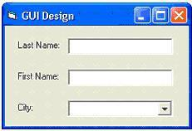

Always set the BackStyle property of label controls to Transparent to make sure your labels have the same BackColor as the parent form.

Whenever you need to prevent users from using a control temporarily, it’s preferable to disable the control rather than hide it. Disabling a control prevents the user from clicking it, but it doesn’t significantly alter the way the form looks. Hiding controls may take your users by surprise or lead them to believe that something is wrong with an application. When selecting controls, also consider newer VB options, such as Tab Control, Tree View, Progress Bar, and Toolbar, to improve the form layout and design.

SCREENSHOTS:

Login Form User Interface Design View
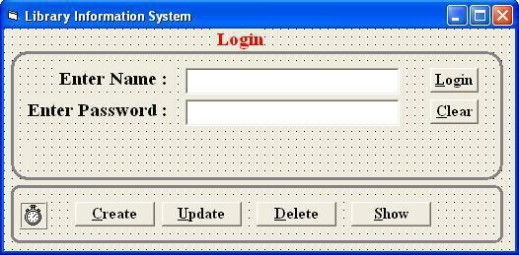

Login Form after Execution
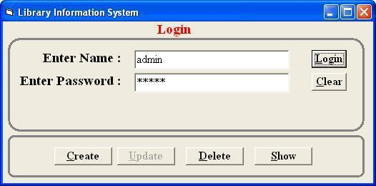

Sample User Interface Design To Display Book Details

Note : Necessary Fields can be added as per Requirement

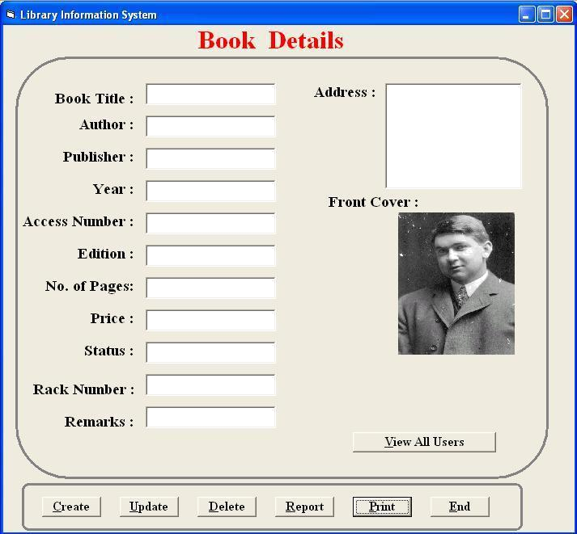

Result

Thus the Library Information system was implement in VB successfully.

Ex. No: 14
Student Information System
Date:

Aim

To develop an application for automating Student Information System

Menu Design

Theory

Adding Menu Bar Using Menu Editor

To start adding menu items to your application, open an existing project or start a new project, then click on Tools in the menu bar of the Visual Basic IDE and select Menu Editor. When you click on the Menu Editor, the Menu Editor dialog will appear. In the Menu Editor dialog , key in the first item File in the caption text box. You can use the ampersand ( & ) sign in front of F so that F will be underlined when it appears in the menu, and F will become the hot key to initiate the action under this item by pressing the Alt key and the letter F. After typing &File in the Caption text box, move to the name textbox to enter the name for this menu item, you can type in mnuFile here. Now, click the Next button and the menu item &File will move into the empty space below, as shown in the following diagram:
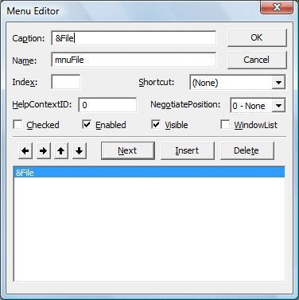

You can then add in other menu items on the menu bar by following the same procedure, as shown in the diagram below:
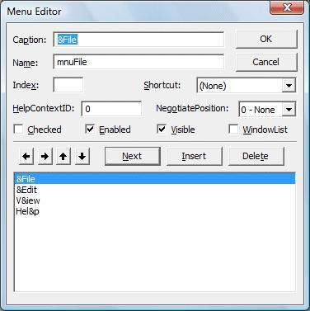

when you click Ok, the menu items will be shown on the menu bar of the form.
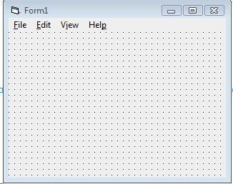

Now, you may proceed to add the sub menus. In the Menu Editor, click on the Insert button between File and Exit and then click the right arrow key, and the dotted line will appear. This

shows the second level of the menu, or the submenu. Now key in the caption and the name. Repeat the same procedure to add other submenu items. Here, we are adding New, Open, Save, Save As and Exit.
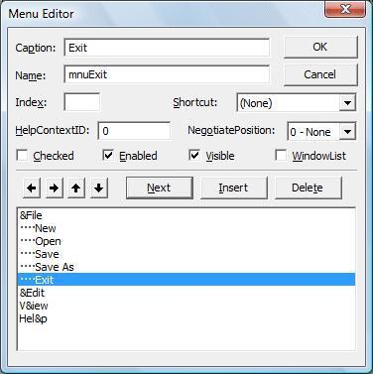

Now click the OK button and go back to your form. You can see the dropped down submenus when you click on the item File, as shown.
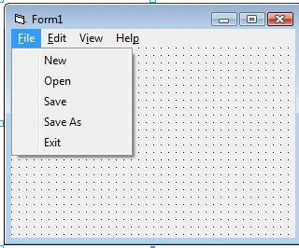

Finally, you can enter the code by clicking on any of the submenu items.

Exercise

  - Add Menu as per Specification and sample 

- given. In the intro form add following Menus

- Personal  

 | Personal Detail |  |  
 | Branch wise Detail
  | Mark  
  | Mark Detail |  
  |  Grade Detail
  | Exit
 
 

- In the Personal Information form add Menu to navigate to the Main Menu(Intro
 | ➢ | Form)   |  
  | ➢ | In the Mark form add Menu to navigate to the Grade Details(Grade Form) |  
  | ➢ | In the Grade form add Menu to navigate to the Mark Details(Mark Form)  
- Add Exit and Back as Required.  
Coding
Sample Coding for Intro Form

Private Sub Exit_Click()
End

End Sub
Private Sub GradeDetail_Click()

Unload Me
Load Grade
Grade.Show

End Sub

Private Sub MarkDetail_Click()
Unload Me
Load Mark

Mark.Show
End Sub

Private Sub PersonalDetail_Click(Index As Integer)
Unload Me

Load Student
Student.Show

End Sub

Sample Coding for Registration Form

Private Sub cmdmovenext_Click()
Adodc1.Recordset.MoveNext

If Adodc1.Recordset.EOF Then
Adodc1.Recordset.MoveLast

End If
End Sub

Private Sub cmdmoveprev_Click()
Adodc1.Recordset.MovePrevious

If Adodc1.Recordset.BOF Then
Adodc1.Recordset.MoveFirst
End If

End Sub

Private Sub cmdnew_Click()
Adodc1.Recordset.AddNew
End Sub

Private Sub cmdsave_Click()

Adodc1.Recordset.Update
End Sub

Private Sub Command1_Click()

cs = "select * from branch where branchname = '" & Adodc2.Recordset("branchname") & "'"

MsgBoxcs
End Sub

Private Sub Mainmenu_Click()
Unload Me

Load Intro
Intro.Show
End Sub
SCREENSHOTS:
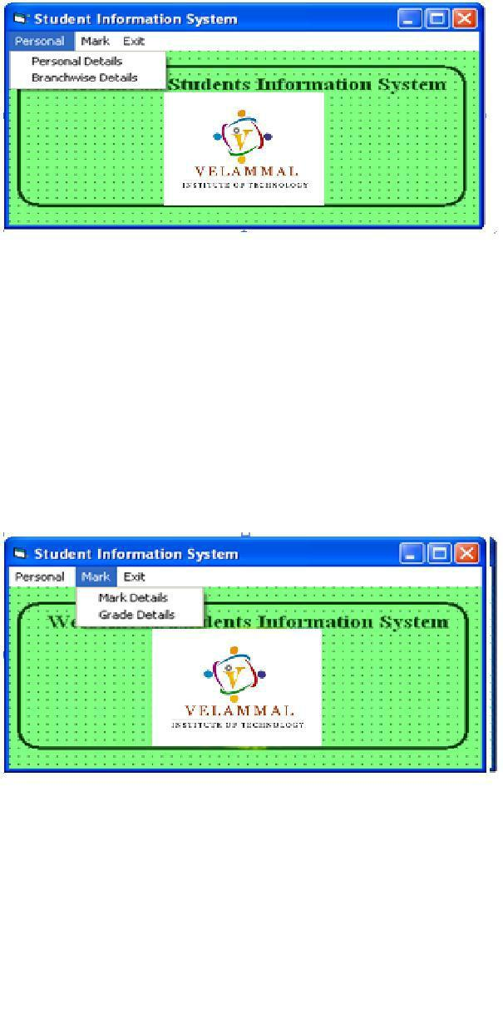

Intro Form:

Registration Form
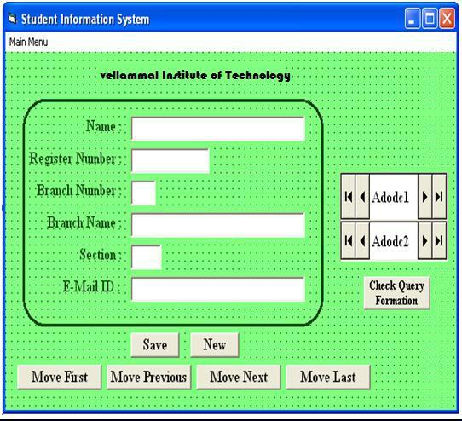

Result

Thus the Library Information System application was created successfully.

Ex. No :15

Simple Calculator
Date :

Aim

To implement a simple calculator by using Visual Basic front end tools.

Procedure:

Step1: create a new project in visual basic using the option file---> new project.

Step2: In the form use the front end tools in the toolbox like textbox, label, command button and create a front end Design for the simple calculator.

Step3: Open the properties window for the toolsand select properties. Now the properties Window is opened.

Step4: Set properties for each tool in the form like caption, name, etc.

Step5: Double click each and every tool to open the project code window.

Step6: write the code for the events of the tools.

Step7: write the code for the simple operations in the calculator like Addition, subtraction, multiplication and division.

Step7: The code is Automatically compiled at the end of each line while pressing the Enter key.

Step7: now execute the code by click the F5 button in the keyboard or select Run--->start.

Step8: after successfully executing the project create the executable file by Select the option file---> make file.exe.

SCREENSHOT:
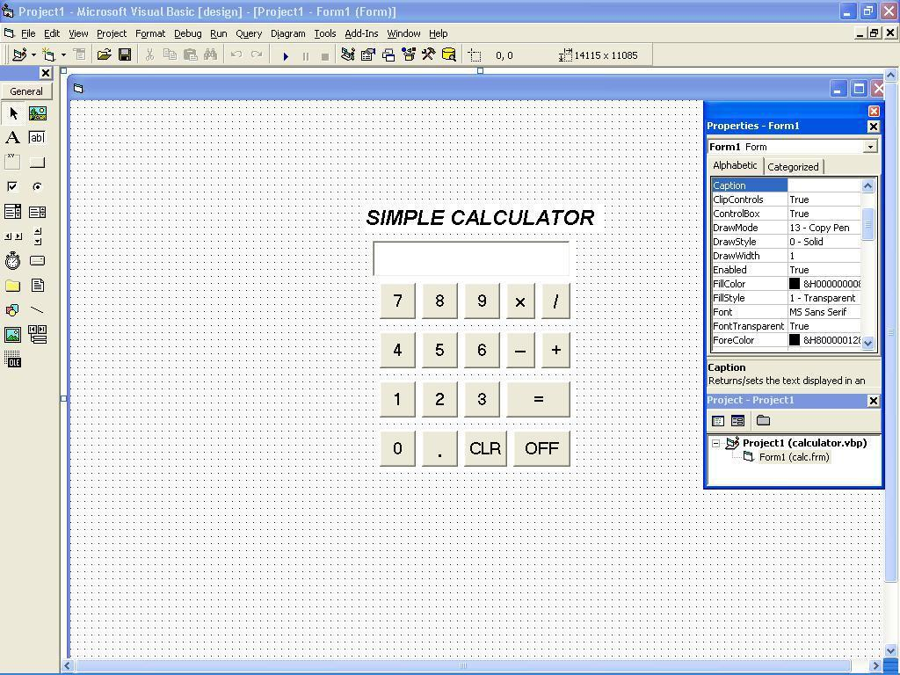

CODING:

Dim a, b, c, d As Integer

Private Sub button0_Click()

display.Text = display.Text +
button0.Caption End Sub

Private Sub button1_Click()

display.Text = display.Text +
button1.Caption End Sub

Private Sub button2_Click()

display.Text = display.Text +
button2.Caption End Sub

Private Sub button3_Click()

display.Text = display.Text +
button3.Caption End Sub

Private Sub button4_Click()

display.Text = display.Text +
button4.Caption End Sub

Private Sub button5_Click()

display.Text = display.Text +
button5.Caption End Sub

Private Sub button6_Click()

display.Text = display.Text +
button6.Caption End Sub

Private Sub button7_Click()

display.Text = display.Text +
button7.Caption End Sub

Private Sub button8_Click()

display.Text = display.Text +
button8.Caption End Sub

Private Sub button9_Click()

display.Text = display.Text +
button9.Caption End Sub

Private Sub add_Click()

a = Val(display.Text)

display.Text = ""

d = 1

End Sub

Private Sub sub_Click()

a = Val(display.Text)

display.Text = ""

d = 2

End Sub

Private Sub mul_Click()

a = Val(display.Text)

display.Text = ""

d = 3

End Sub

Private Sub div_Click()

a = Val(display.Text)

display.Text = ""

d = 4

End Sub

Private Sub equalto_Click()

b = Val(display.Text)

If d = 1 Then

c = a + b

display.Text = c
ElseIf d = 2

Then c = a - b
display.Text = c
ElseIf d = 3

Then c = a * b
display.Text = c

ElseIf d = 4
Then c = a / b

display.Text = c
End If

End Sub

Private Sub
clear_Click() a = 0

b = 0
c = 0

display.Text =
"" End Sub

Private Sub off_Click()

MSG = MsgBox("THANKS FOR USING FX990ES FROM NASA COPY RIGHTS RESERVED", vbOKOnly, "BYE")

End End

Sub

Private Sub decimalpoint_Click()

display.Text = display.Text +
decimalpoint.Caption End Sub
OUTPUT:
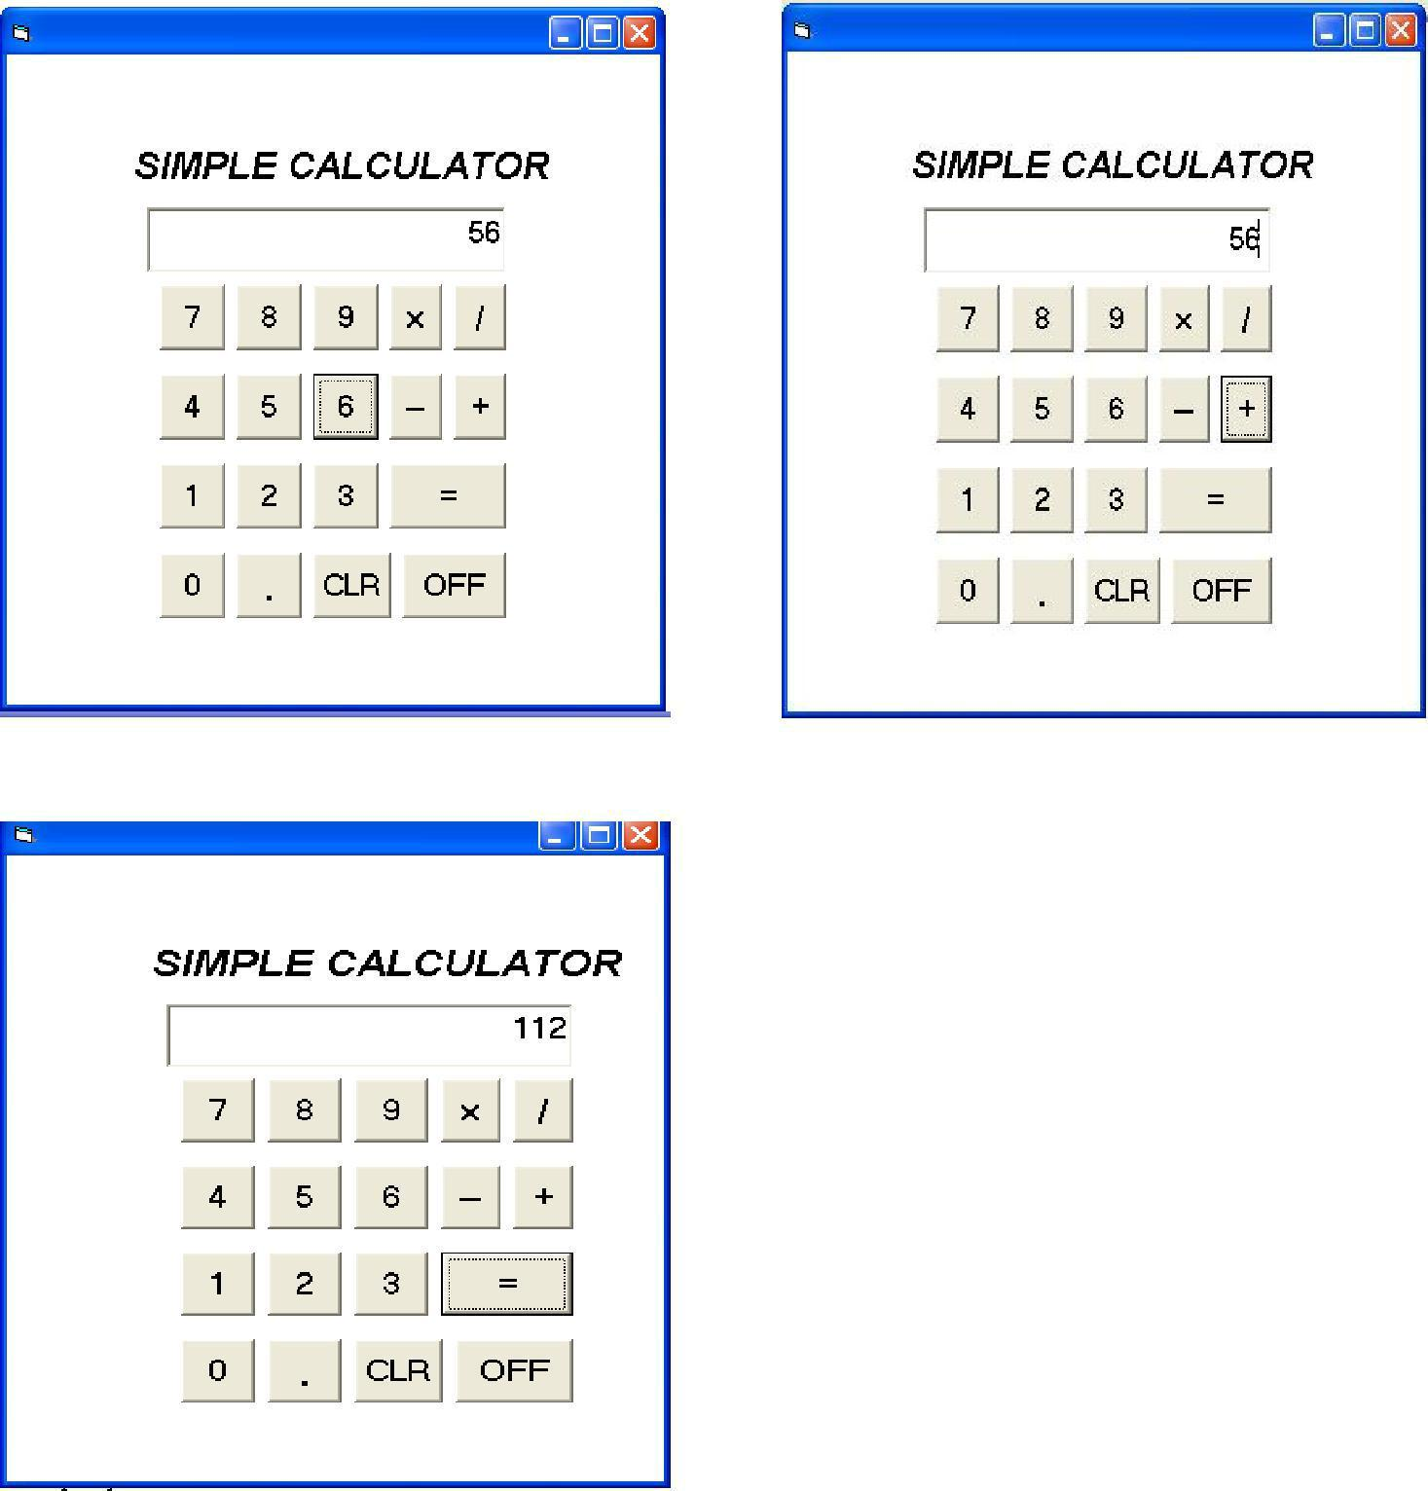

Result

Thus the simple calculator application was created successfully.

Content beyond the Syllabus

MongoDB

MongoDBOverview

MongoDB is a cross-platform, document oriented database that provides, high performance, high availability, and easy scalability. MongoDB works on concept of collection and document.

Database
Database is a physical container for collections. Each database gets its own set of files on the file system. A single MongoDB server typically has multiple databases.

Collection
Collection is a group of MongoDB documents. It is the equivalent of an RDBMS table. A collection exists within a single database. Collections do not enforce a schema. Documents within a collection can have different fields. Typically, all documents in a collection are of similar or related purpose.

Document
A document is a set of key-value pairs. Documents have dynamic schema. Dynamic schema means that documents in the same collection do not need to have the same set of fields or structure, and common fields in a collection's documents may hold different types of data.

The following table shows the relationship of RDBMS terminology with MongoDB.

RDBMS | MongoDB
Database | Database
Table | Collection
Tuple/Row | Document
column | Field
Table Join | Embedded Documents
Primary Key | Primary Key (Default key _id provided by mongodb itself)
Database Server and Client
Mysqld/Oracle | mongod
mysql/sqlplus | mongo

Sample Document
Following example shows the document structure of a blog site, which is simply a comma separated key value pair.

{

_id: ObjectId(7df78ad8902c)
title: 'MongoDB Overview',

description: 'MongoDB is no sql database',
by: 'tutorials point',

url: 'http://www.tutorialspoint.com',
tags: ['mongodb', 'database', 'NoSQL'],

likes: 100,

comments: [
{

user:'user1',
message: 'My first comment',

dateCreated: new Date(2011,1,20,2,15),
like: 0

},

{
user:'user2',

message: 'My second comments',
dateCreated: new Date(2011,1,25,7,45),

like: 5
}

]

}

_id is a 12 bytes hexadecimal number which assures the uniqueness of every document. You can provide _id while inserting the document. If you don’t provide then MongoDB provides a unique id for every document. These 12 bytes first 4 bytes for the current timestamp, next 3 bytes for machine id, next 2 bytes for process id of MongoDB server and remaining 3 bytes are simple incremental VALUE.

MongoDB─Advantages

Any relational database has a typical schema design that shows number of tables and the relationship between these tables. While in MongoDB, there is no concept of relationship.

Advantages of MongoDB over RDBMS
• Schemaless:MongoDB is a documentdatabaseinwhich onecollectionholds different documents. Number of fields, content and size of the document can differ from one document to another.

• Structure of a single object is clear.

• No complex joins.

• Deep query-ability. MongoDB supports dynamic queries on documents using a document-based query language that's nearly as powerful as SQL.

• Tuning.

• Ease of scale-out: MongoDB is easy to scale.

• Conversion/mapping of application objects to database objects not needed.

• Uses internal memory for storing the (windowed) working set, enabling faster access of data.

Why Use MongoDB?
• Document Oriented Storage: Data is stored in the form of JSON style documents. • Index on any attribute
• Replication and high availability • Auto-sharding
• Rich queries
• Fast in-place updates

• Professional support by MongoDB

Where to Use MongoDB? • Big Data
• Content Management and Delivery • Mobile and Social Infrastructure

MongoDB─Environment

Let us now see how to install MongoDB on Windows.

Install MongoDB on Windows
To install MongoDB on Windows, first download the latest release of MongoDB from http://www.mongodb.org/downloads. Make sure you get correct version of MongoDB depending upon your Windows version. To get your Windows version, open command prompt and execute the following command.

C:\>wmic os get osarchitecture

OSArchitecture
64-bit

C:\>

32-bit versions of MongoDB only support databases smaller than 2GB and suitable only for testing and evaluation purposes.

Now extract your downloaded file to c:\ drive or any other location. Make sure the name of the extracted folder is mongodb-win32-i386-[version] or mongodb-win32-x86_64-[version]. Here [version] is the version of MongoDB download.

Next, open the command prompt and run the following command.

C:\>move mongodb-win64-* mongodb

1 dir(s) moved.

C:\>

In case you have extracted the MongoDB at different location, then go to that path by using command cd FOOLDER/DIR and now run the above given process.

MongoDB requires a data folder to store its files. The default location for the MongoDB data directory is c:\data\db. So you need to create this folder using the Command Prompt. Execute the following command sequence.

C:\>md data

C:\md data\db

IfyouhavetoinstalltheMongoDBata differentlocation, thenyouneedtospecify analternate path for \data\db by setting the path dbpath in mongod.exe. For the same, issue the following commands.

In the command prompt, navigate to the bin directory present in the MongoDB installation folder. Suppose my installation folder is D:\set up\mongodb

C:\Users\XYZ>d:

D:\>cd "set up"

D:\set up>cd mongodb
D:\set up\mongodb>cd bin

D:\set up\mongodb\bin>mongod.exe --dbpath "d:\set up\mongodb\data"

This will show waiting for connections message on the console output, which indicates that the mongod.exe process is running successfully.

Now to run the MongoDB, you need to open another command prompt and issue the following command.

D:\set up\mongodb\bin>mongo.exe

MongoDB shell version: 2.4.6
connecting to: test

>db.test.save( { a: 1 } )
>db.test.find()

{ "_id" : ObjectId(5879b0f65a56a454), "a" : 1 }
>

This will show that MongoDB is installed and run successfully. Next time when you run MongoDB, you need to issue only commands.

D:\set up\mongodb\bin>mongod.exe --dbpath "d:\set up\mongodb\data"

D:\set up\mongodb\bin>mongo.exe

Install MongoDB on Ubuntu
Run the following command to import the MongoDB public GPG key −

sudo apt-key adv --keyserver hkp://keyserver.ubuntu.com:80 --recv 7F0CEB10

Create a /etc/apt/sources.list.d/mongodb.list file using the following command.

echo 'deb http://downloads-distro.mongodb.org/repo/ubuntu-upstart dist 10gen'
| sudo tee /etc/apt/sources.list.d/mongodb.list

Now issue the following command to update the repository −

sudo apt-get update

Next install the MongoDB by using the following command −

apt-get install mongodb-10gen=2.2.3

In the above installation, 2.2.3 is currently released MongoDB version. Make sure to install the latest version always. Now MongoDB is installed successfully.

Start MongoDB

sudo service mongodb start

Stop MongoDB

sudo service mongodb stop

Restart MongoDB

sudo service mongodb restart

To use MongoDB run the following command.

mongo

This will connect you to running MongoDB instance.

MongoDB Help
To get a list of commands, type db.help() in MongoDB client. This will give you a list of commands as shown in the following screenshot.

MongoDB Statistics
To get stats about MongoDB server, type the command db.stats() in MongoDB client. This will show the database name, number of collection and documents in the database. Output of the command is shown in the following screenshot.

MongoDB - CreateDatabase

In this chapter, we will see how to create a database in MongoDB.

The use Command
MongoDB use DATABASE_NAME is used to create database. The command will create a new database if it doesn't exist, otherwise it will return the existing database.

Syntax
Basic syntax of use DATABASE statement is as follows:
use DATABASE_NAME

Example
If youwantto createa databasewithname <mydb>, then useDATABASE statementwould be as follows:
>use mydb

switched to db mydb

To check your currently selected database, use the command db
>db

mydb

If you want to check your databases list, use the command show dbs.
>show dbs

local 0.78125GB
test 0.23012GB

Your created database (mydb) is not present in list. To display database, you need to insert at least one document into it.
>db.movie.insert({"name":"tutorials point"})

>show dbs
local

mydb

0.78125GB

0.23012GB test 0.23012GB

In MongoDB default database is test. If you didn't create any database, then collections will be stored in test database.

MongoDB─DropDatabase

In this chapter, we will see how to drop a database using MongoDB command.

The dropDatabase() Method
MongoDB db.dropDatabase() command is used to drop a existing database.

Syntax
Basic syntax of dropDatabase() command is as follows:

db.dropDatabase()

This will delete the selected database. If you have not selected any database, then it will delete default 'test' database.

Example
First, check the list of available databases by using the command, show dbs.

>show dbs

local
mydb

test
>

0.78125GB
0.23012GB

0.23012GB

If you want to delete new database <mydb>, then dropDatabase() command would be as follows:
>use mydb

switched to db mydb

>db.dropDatabase()
>{ "dropped" : "mydb", "ok" : 1 }

>
Now check list of databases.

>show dbs

local

test

0.78125GB

0.23012GB

MongoDB─CreateCollection

In this chapter, we will see how to create a collection using MongoDB.

The createCollection() Method
MongoDB db.createCollection(name, options) is used to create collection.

Syntax
Basic syntax of createCollection() command is as follows:

db.createCollection(name, options)

In the command, name is name of collection to be created. Options is a document and is used to specify configuration of collection.

Parameter | Type | Description
Name | String | Name of the collection to be created
Options | Document | (Optional) Specify options about memory size and indexing

Options parameter is optional, so you need to specify only the name of the collection. Following is the list of options you can use:

Field | Type | Description
capped | Boolean | (Optional) If true, enables a capped collection. Capped collection is a fixed size collection that automatically overwrites its oldest entries when it reaches its maximum size. If you specify true, you need to specify size parameter also.
autoIndexID | Boolean | (Optional) If true, automatically create index on _id field. Default value is false.
size | number | (Optional) Specifies a maximum size in bytes for a capped collection. If capped is true, then you need to specify this field also.

max | number | (Optional) Specifies the maximum number of documents allowed in the capped collection.

While inserting the document, MongoDB first checks size field of capped collection, then it checks max field.

Examples
Basic syntax of createCollection() method without options is as follows:

>use test

switched to db test

>db.createCollection("mycollection")
{ "ok" : 1 }

>

You can check the created collection by using the command show collections.

>show collections

mycollection

system.indexes

The following example shows the syntax of createCollection() method with few important options:

>db.createCollection("mycol", { capped : true, autoIndexID : true, size : 6142800, max : 10000 } )
{ "ok" : 1 }

>
In MongoDB, you don't need to create collection. MongoDB creates collection automatically, when you insert some document.

>db.tutorialspoint.insert({"name" : "tutorialspoint"})
>show collections

mycol

mycollection
system.indexes

tutorialspoint
>

